**Mastering Multi-Cloud**

**Labs: Multi-Cloud Architecture and Networking**

**Lab 01: Launching an EC2 Instance in a Custom Virtual Private Cloud (VPC)**

**Case Study**

Airbnb is a global online marketplace that connects travelers with hosts offering unique accommodations and experiences. Operating in more than 220 countries and regions, Airbnb relies on highly available and secure cloud infrastructure to support its website, mobile applications, booking systems, and payment processing services. To meet these demands, Airbnb uses Amazon Web Services (AWS) as its primary cloud platform.

As the company expanded rapidly, Airbnb needed greater control over its network environment to isolate workloads, enhance security, and optimize traffic flow. To achieve this, Airbnb implemented custom Virtual Private Clouds (VPCs) on AWS. This allowed the organization to design private networks with defined IP address ranges, subnets, routing tables, and security policies tailored to different application environments.

By deploying EC2 instances within custom VPCs, Airbnb ensures that its compute resources run in a controlled and secure environment, supporting business-critical applications while meeting compliance and performance requirements.

**Business Challenge**

As Airbnb scaled globally, managing network security and traffic within a shared cloud environment became complex. Default networking configurations limited the company’s ability to segment workloads, restrict access, and enforce custom security policies. This created risks such as unauthorized access, inefficient routing, and potential compliance gaps.

Additionally, separating development, testing, and production environments was critical to prevent conflicts and security breaches. Airbnb’s cloud engineering team identified the need for a custom VPC architecture to gain full control over network design, improve security posture, and enable scalable application deployment. Launching EC2 instances within a custom VPC was key to meeting these objectives.

**Solution**

In this lab, AWS is used to demonstrate how Airbnb can securely deploy compute resources within a custom network. You will create a custom VPC with a defined CIDR block, configure public and private subnets, and set up route tables and an Internet Gateway to control traffic flow.

After configuring the VPC, you will launch an EC2 instance inside a selected subnet. Security Groups will be configured to allow only authorized inbound and outbound traffic. You will also assign a public IP address to enable secure remote access.

Amazon EC2 provides scalable virtual servers, while Amazon VPC enables organizations to build isolated cloud networks. Together, these services allow enterprises like Airbnb to deploy applications in a secure, controlled, and highly available environment.

Through this lab, learners gain hands-on experience in:

* Designing a custom Virtual Private Cloud (VPC)
* Configuring subnets, route tables, and Internet Gateways
* Launching and managing Amazon EC2 instances
* Applying AWS security best practices using Security Groups and network controls
* Supporting real-world enterprise workloads in a secure cloud environment



**Follow the given steps to launch an EC2 instance in a custom VPC.**

1. Log in to your AWS Console.
2. Click on **Services**.
3. Select VPC from **Networking & Content Delivery**.

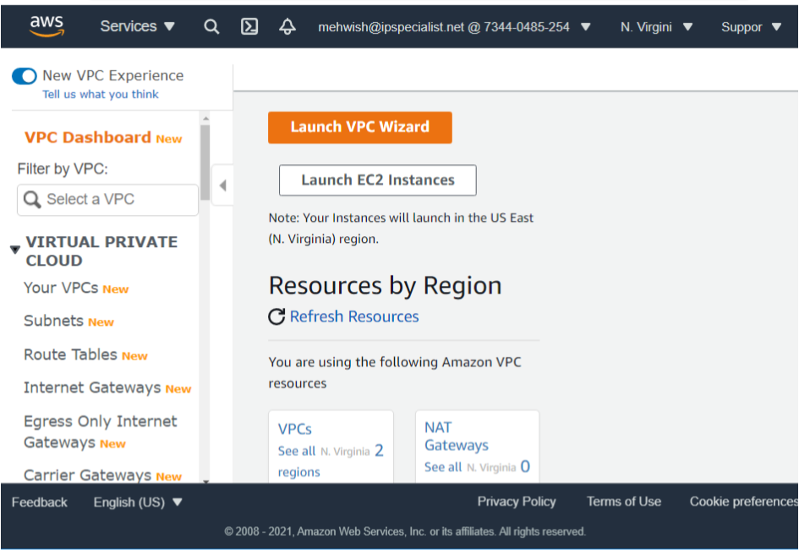

1. It brings us to the initial VPC dashboard. In this, we will create a custom VPC.

**Note:** VPC allows you to create a private network that is isolated from other private networks in AWS to secure your resources. Create a VPC from scratch. Do not use the **Launch VPC Wizard**.

1. To create a VPC, navigate to the left-hand side and click on **Your VPCs**.

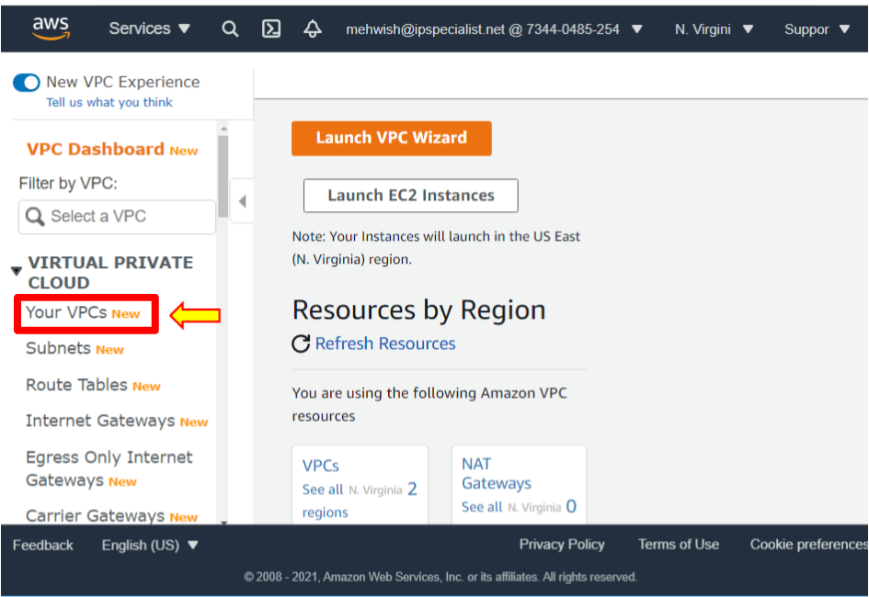

1. Now, you see the dashboard. In the upper right-hand corner, click **Create VPC**.

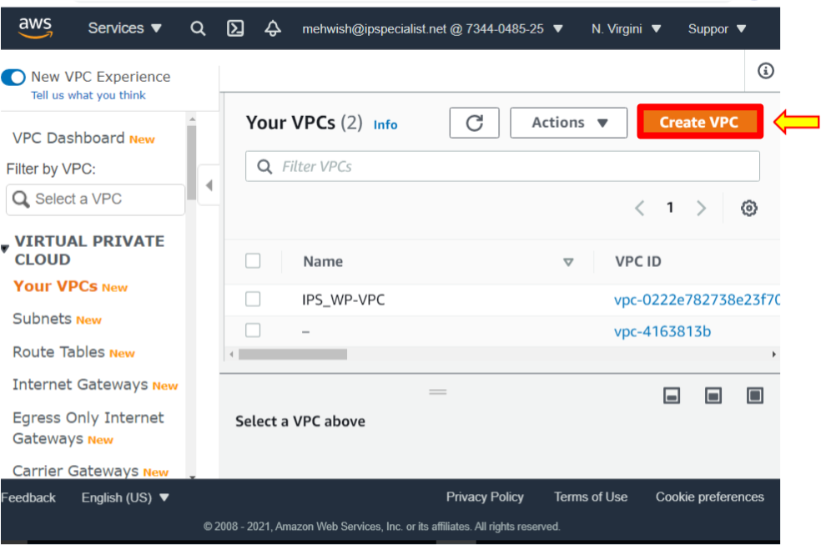

1. Now, give VPC a name; let us call it **IPS-HolVPC.**
2. Enter the CIDR block, which is the IP address range for this VPC. Type **10.0.0.0/16**.
3. You should not use IPv6 CIDR blocks and make sure no IPv6 CIDR Block is selected.
4. Leave **Tenancy** as it is the default. It means you are using shared hardware.
5. The other option is dedicated. It means you have dedicated hardware, but leave it default.

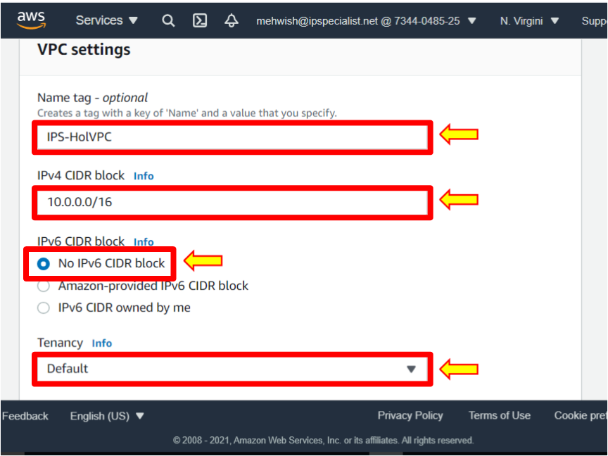

1. Leave the default tag. This is the name of VPC. You can add additional tags like the department this VPC is associated with, marketing department, IT department, etc., but leave the name for now.
2. Click **Create VPC**, and your VPC is now up and running.

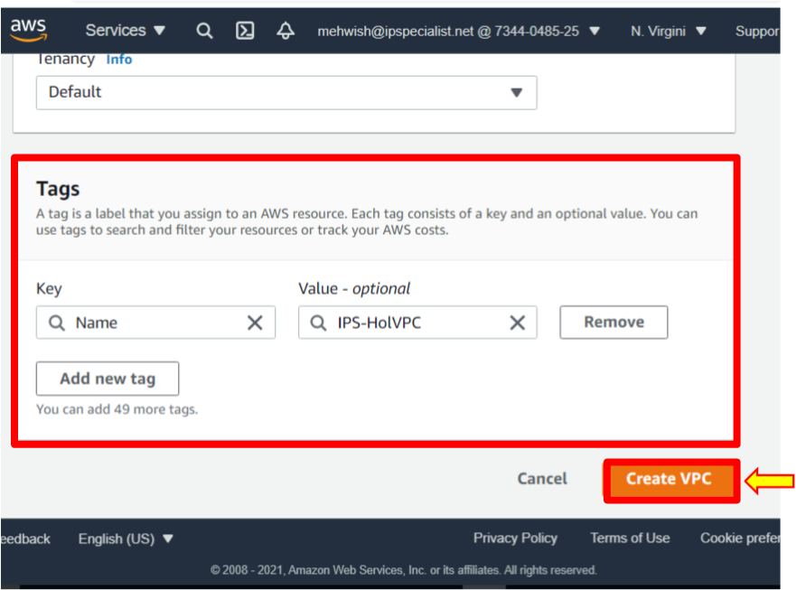

1. Now, create the public and private subnets.
2. VPCs contain subnets or isolated local networks that use a subnet of the CIDR block range to find the overall VPC. Launch your resources and services directly in a subnet, so services like EC2 instances are not typically launched directly in a VPC; they are launched in a subnet.
3. On the left-hand side, click **Subnets** to create a subnet.

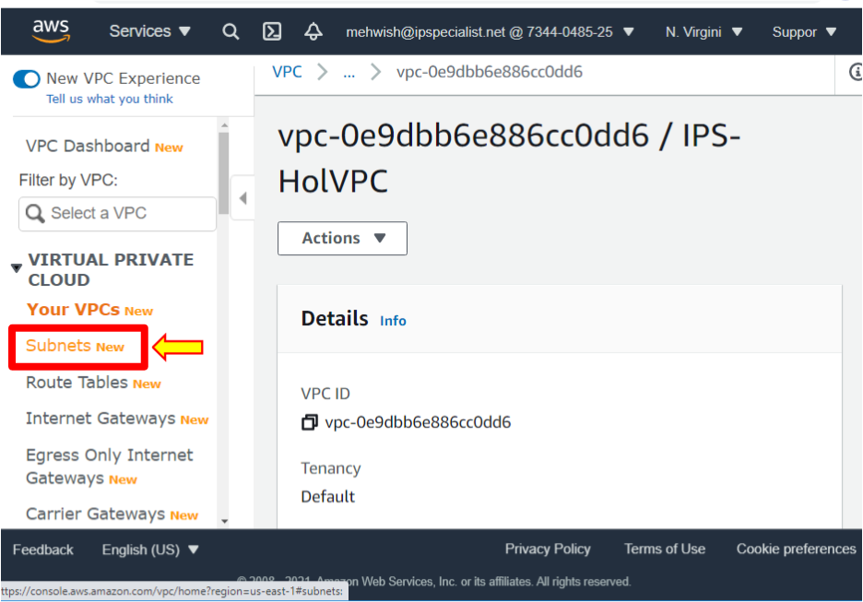

1. Click **Create Subnet**.

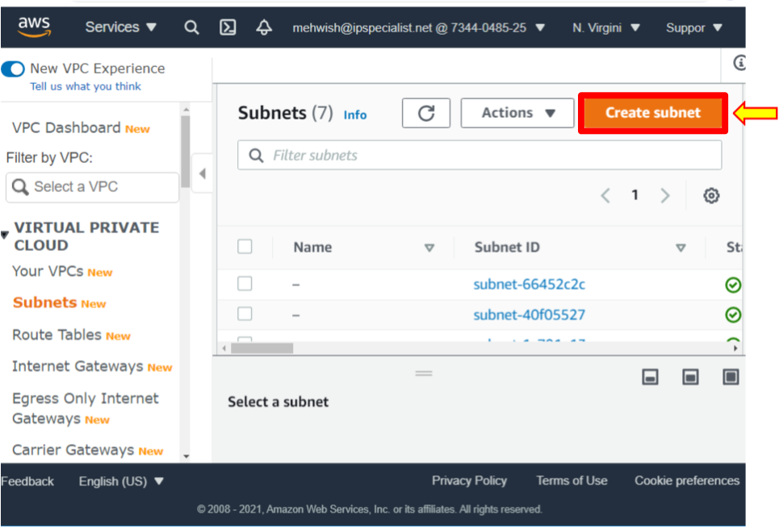

1. Select the VPC we created, **IPS-HoLVPC**.

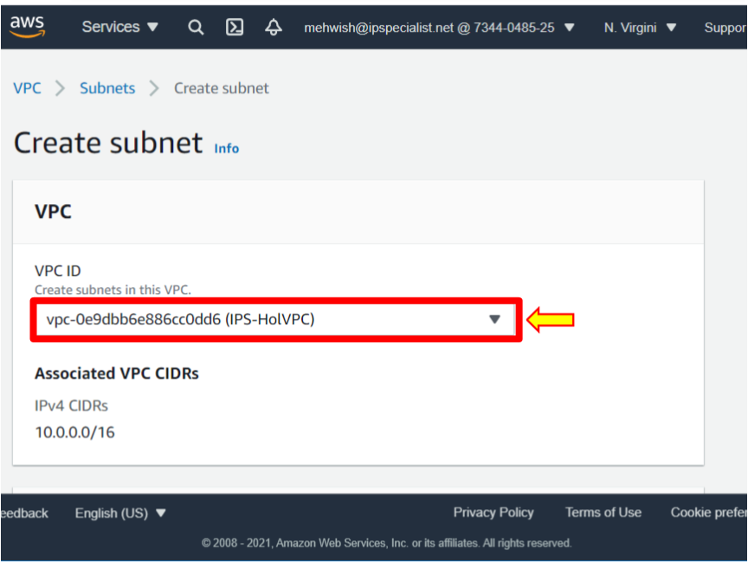

1. Give the subnet the name **IPS-snpublic-a**. Therefore, this is a public subnet.
2. When creating a subnet, you must select the availability zone. Each subnet must reside entirely within one availability zone and cannot span zones.
3. Put this subnet in **us-east-1a**.
4. VPC CIDR shows the CIDR block range for the VPC. When you create a subnet, you specify the CIDR block for that subnet; in this case, type **10.0.1.0/24**.

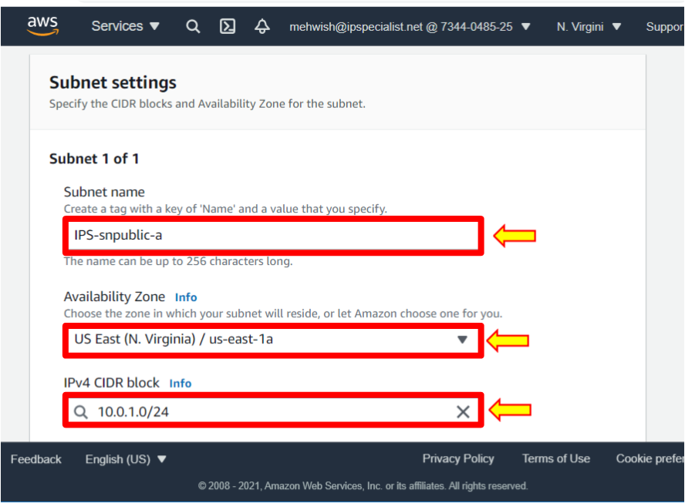

1. Click **Create Subnet**.

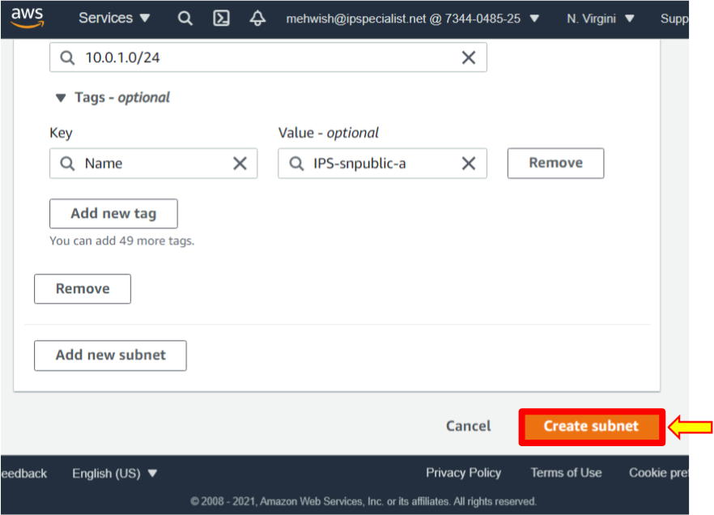

1. After that, you will see that the state of the subnet is available.
2. Although we named this subnet a public subnet, it is not public just yet; there are additional configurations to make it publicly available over the internet.

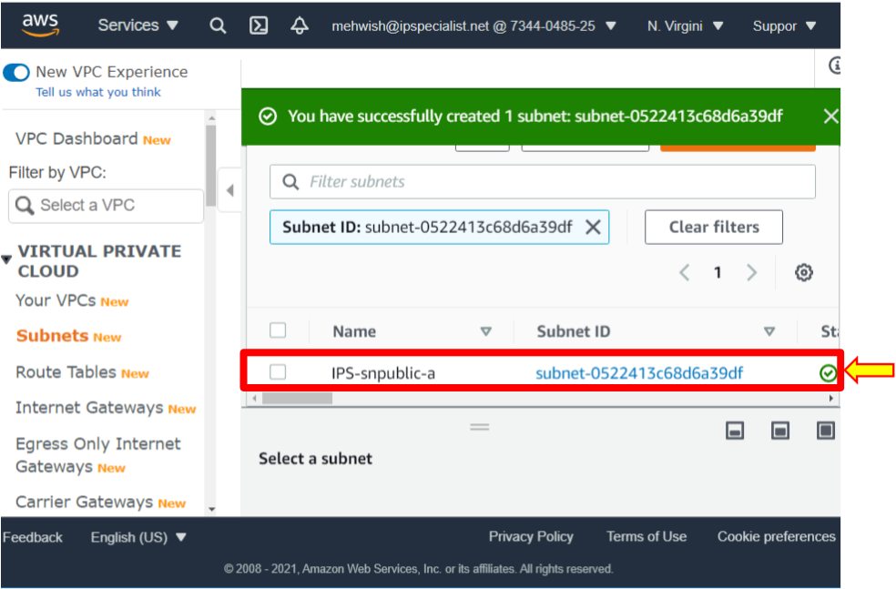

1. Next, create a private subnet that follows the same path.
2. Click **Create Subnet**.
3. Select the VPC that was created.
4. Give the subnet the name **IPS-snprivate-b**.
5. This time, for the availability zone, select **us-east-1b**.
6. For the CIDR block range, type **10.0.2.0/24**.

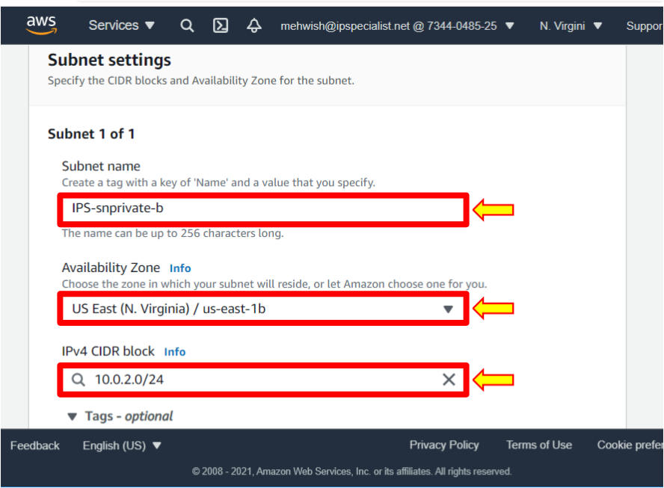

1. Click **Create Subnet**.
2. Created two subnets in VPC, one public subnet and one private subnet.

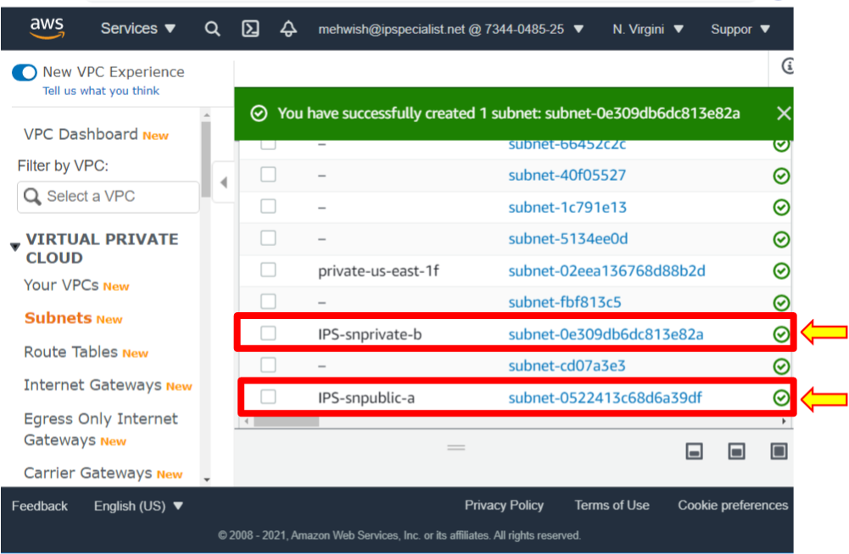

1. Now, we will look at the routing inside VPC, which defines traffic within subnets and from the internet. There is one route table per VPC.
2. Click on **Routes Tables**.

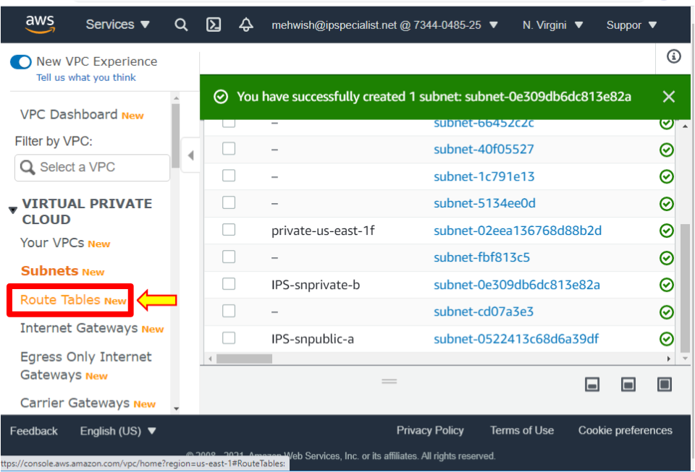

1. To see the **Route tables**, scroll down and click on **Routes.**

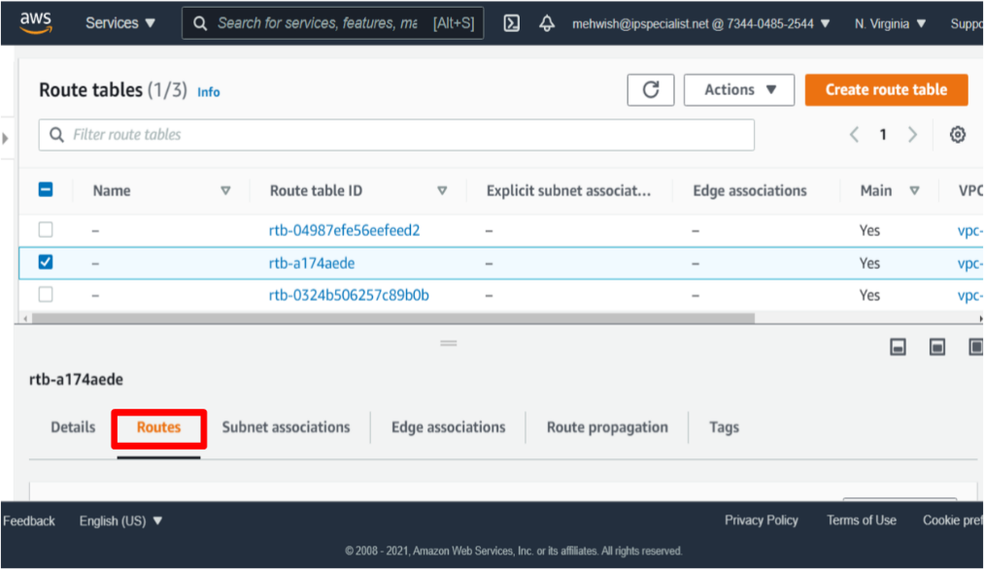

**Note:** This route allows traffic to pass to other nodes within the network but does not allow traffic outside the network, such as to the public internet. All VPCs you create by default get associated with the main route table.

1. To make a public subnet public, select **Subnets.**
2. Select the **Public Subnet**.
3. Click on **Actions** and click **Modify Auto-Assign IP Settings**.

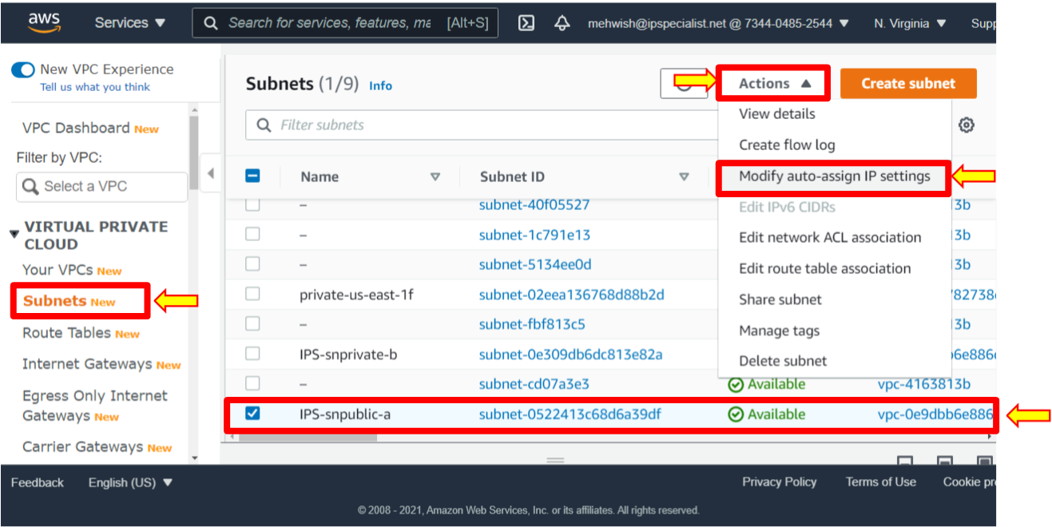

1. Click **Enable** **Auto-Assigned Public IPv4 Addresses**.
2. Since the launched instances in this subnet set the automatic request for a public IPv4 address for instances.
3. Click **Save** and configure the internet gateway.

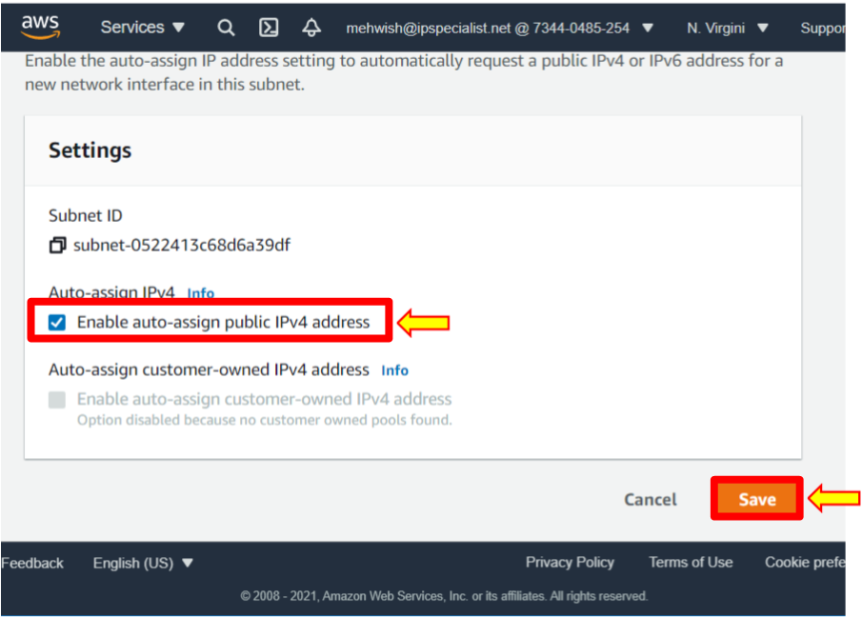

1. Click **Internet Gateways**, then click **Create internet gateway**.

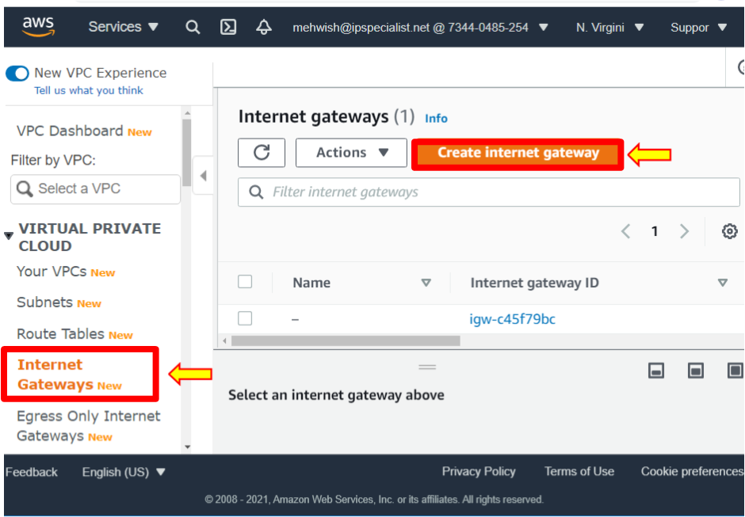

1. The internet gateway is a virtual router that allows the VPC to connect to the internet. Give a name to the internet gateway **IPS-holVPCIGW**. Leave the name as the default tag.
2. You can add additional description tags to help you track and monitor this internet gateway, but for now, leave your name and click **Create internet gateway**.

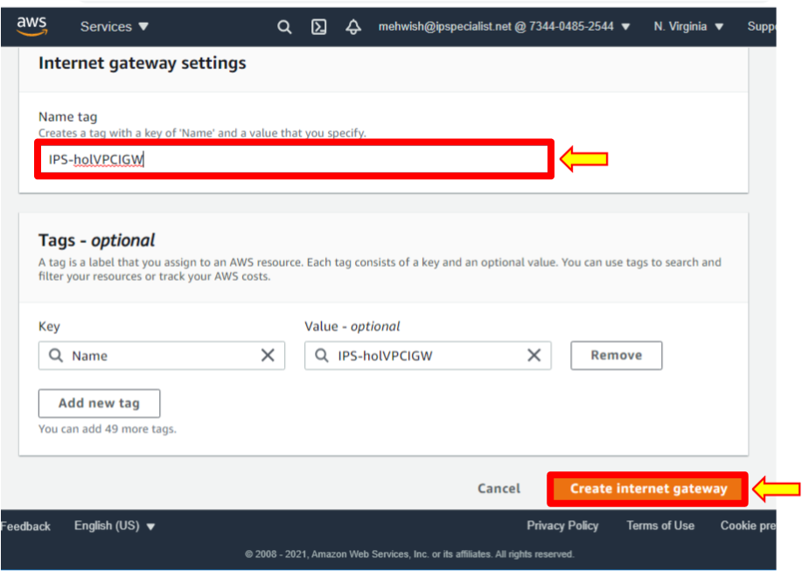

1. Notice that the created internet gateway is in the state of **detached** and requires something for connection.
2. In this case, attach the internet gateway to the VPC. You can do that by clicking on **Actions** in the upper right-hand corner and then clicking **Attach to VPC**. Select the VPC that created **IPS-HoLVPC**.

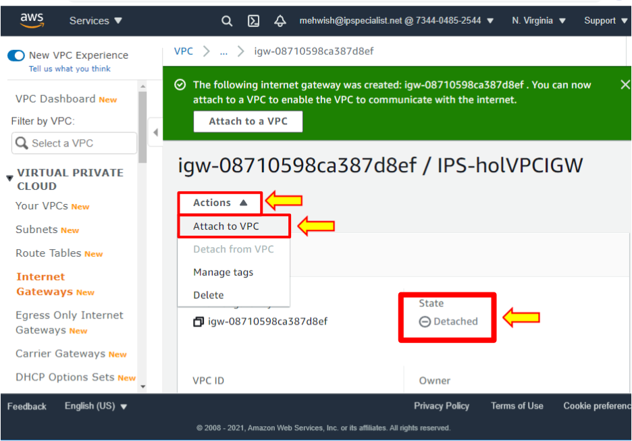

1. Click **Attach internet gateway**.

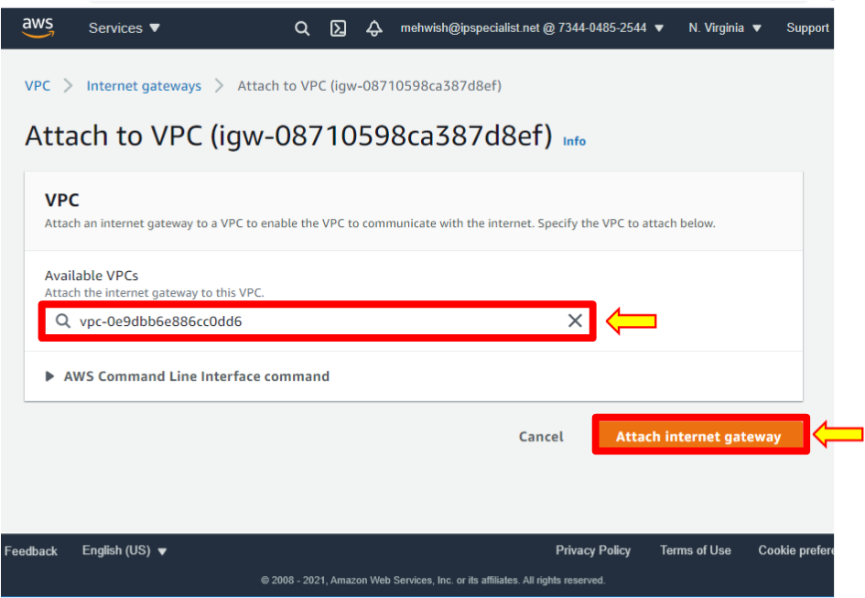

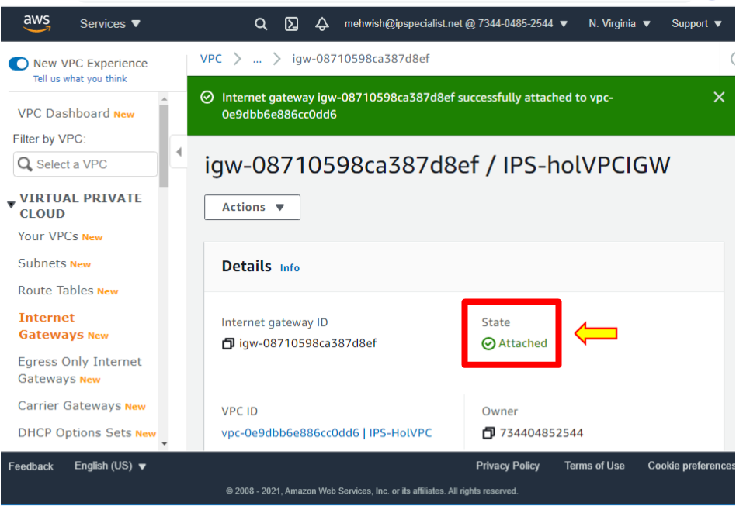

1. To set up the internet gateway, you need to configure routing.
2. Now, go back to the route tables. Leave this default route table as is.
3. In all VPCs, you create, by default, get associated with the main route table.
4. Create a route table for public internet traffic by clicking on **Create Route table**.

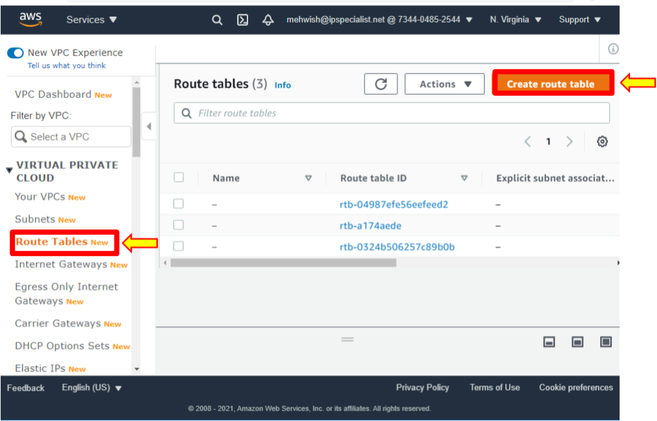

1. Name this **IPS-publicRT** for the route table and select the created VPC. Please do not add a tag; leave it as the default. Click on **Create**.

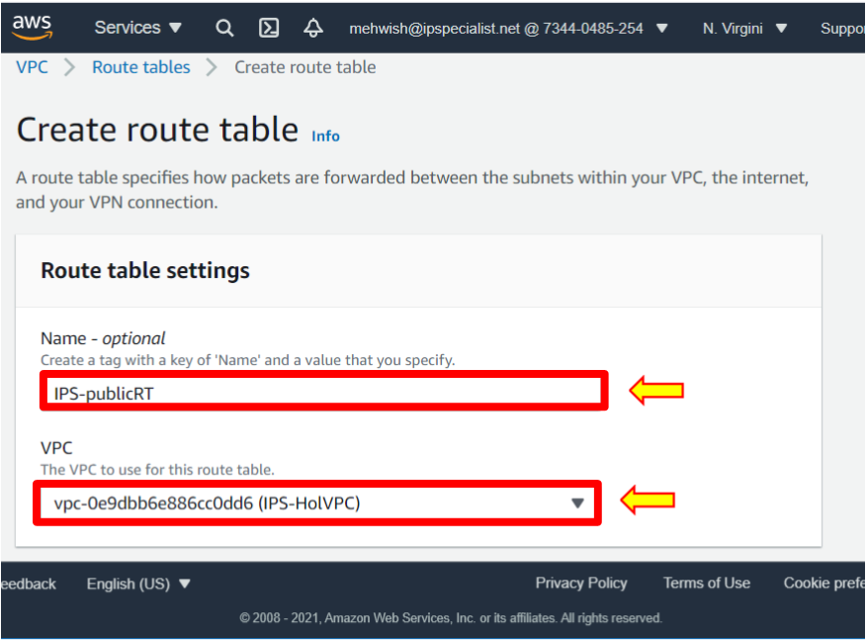

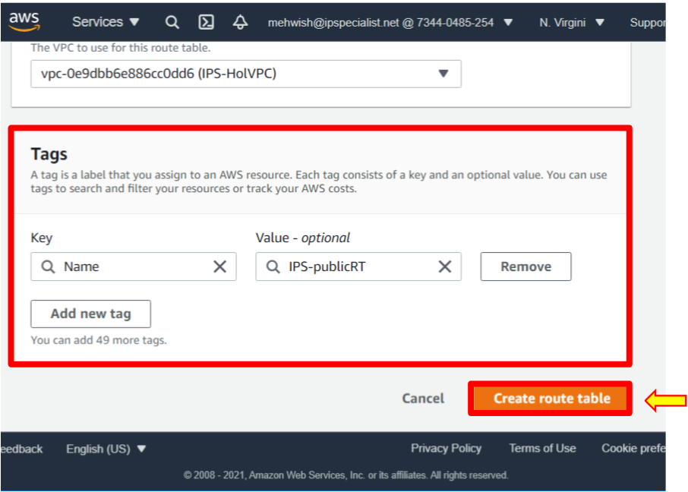

1. Then, select the newly created route table.
2. Click the **Routes** tab. The local route allows traffic to pass to other nodes within the network but does not allow traffic to go outside the network, such as to the public internet. So fix that.
3. Click on **Edit Routes**.

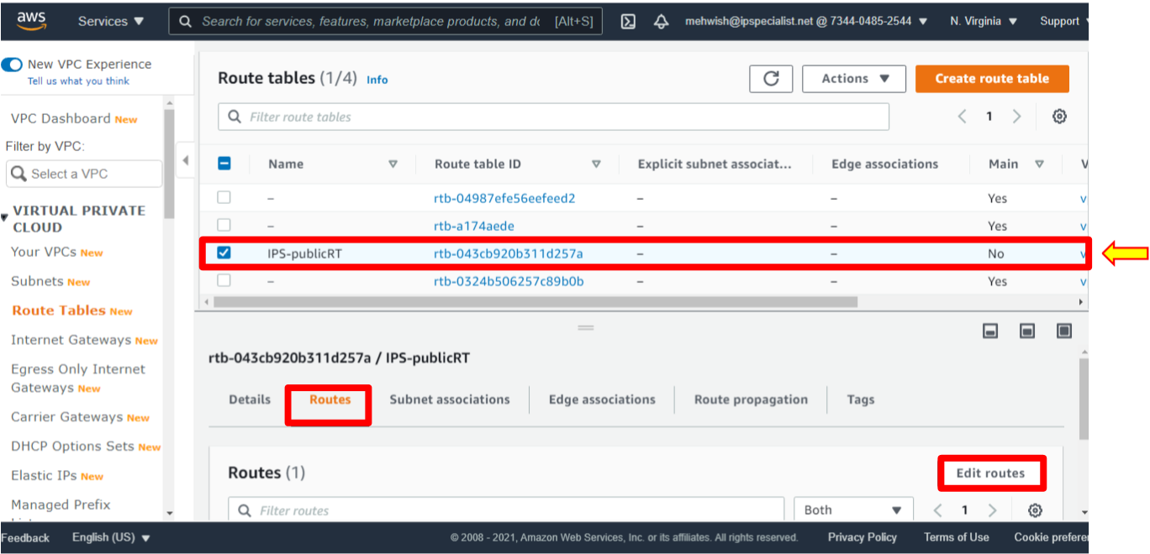

1. Click **Add route**, set destination zero **0.0.0.0/0**, and type the default value. It essentially represents the public internet.
2. Select targets as the **Internet Gateway**.
3. Select the internet gateway that was created.
4. Click **Save Changes**.

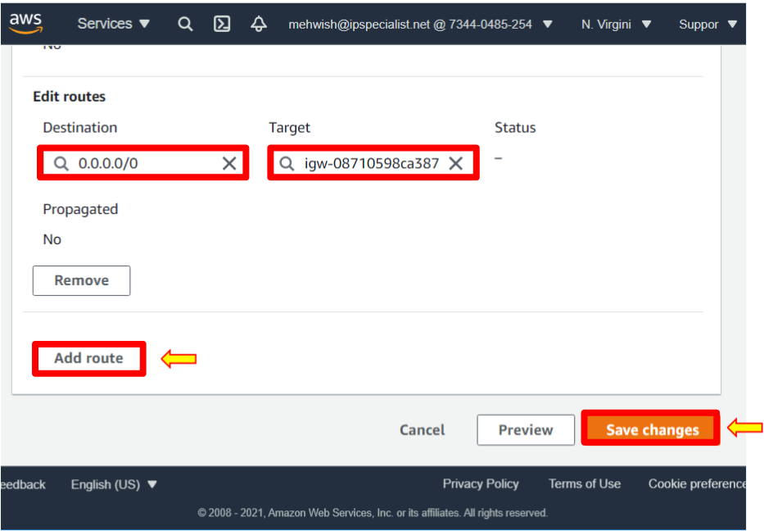

1. The public route table is now created.
2. The traffic is allowed on the public internet.
3. Now, associate this route table with the public subnet. To do this, make sure the public route table is selected.
4. Click on the subnet associations tab.
5. Click **Edit** subnet associations.

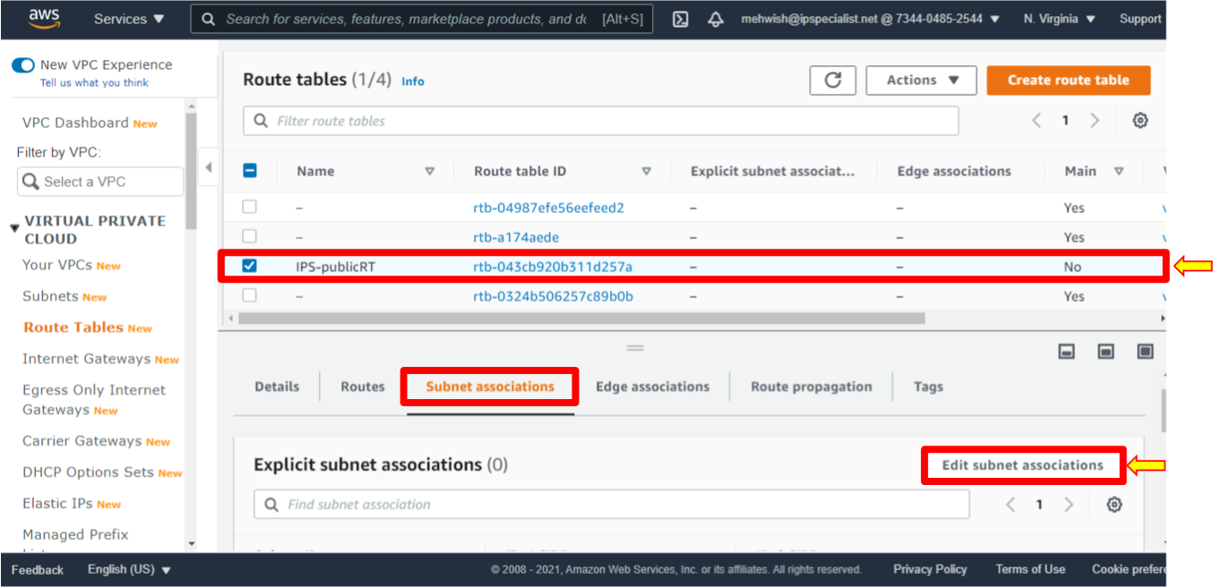

1. In this case, select the public subnet **IPS-sn-public-a** and notice it is now associated with the main or default route table.
2. Change the subnet association, select it, and click **Save associations**.

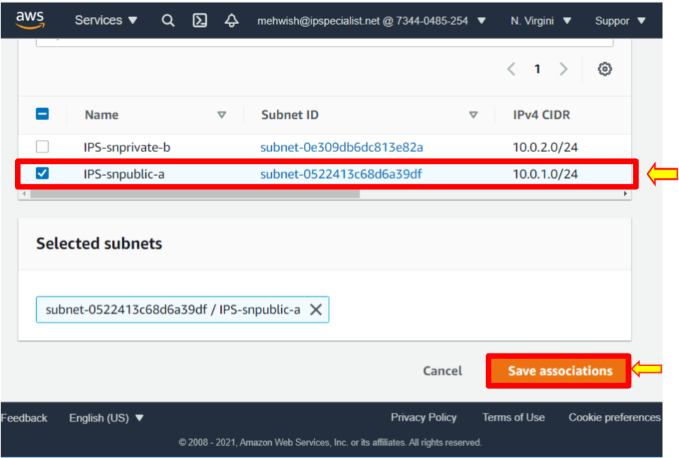

1. The public subnet allows traffic to access the public internet. Click on **Subnets**.
2. Select the public subnet.
3. Click on the **Route table** and see that it is associated with the public route table.

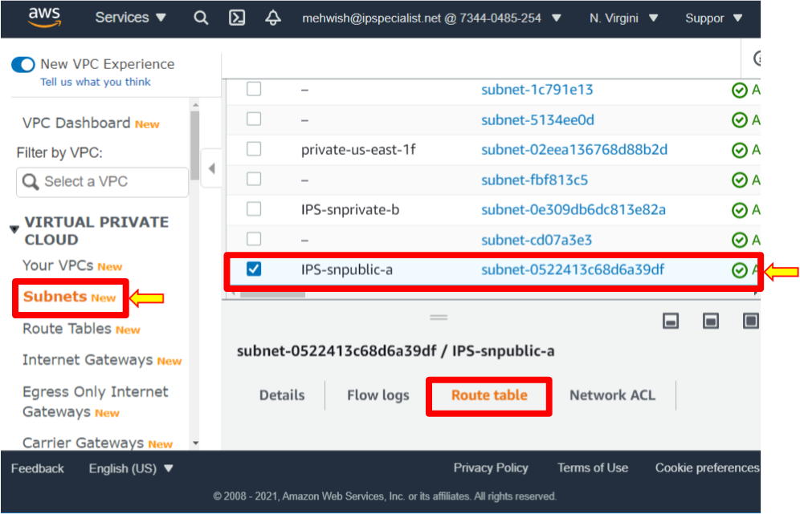

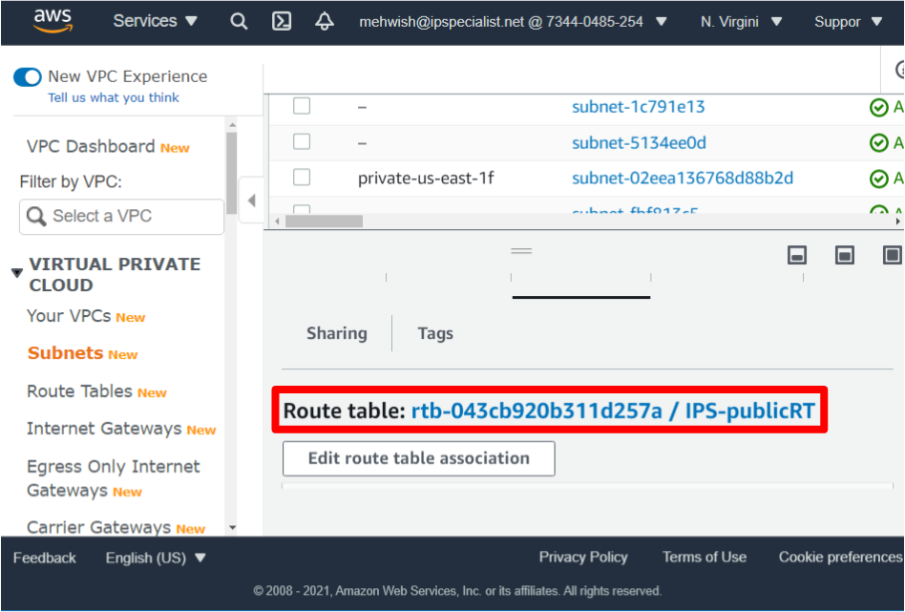

1. Click on a private subnet.
2. Notice the route table is the default route table.

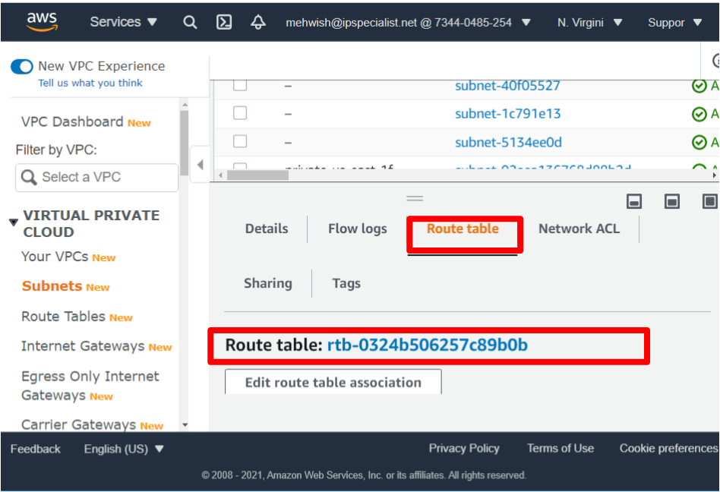

1. Notice that you do not change the configuration for this private subnet because if a subnet does not have any route to the internet gateway, then the subnet is known as a private subnet. Therefore, the instance in this private subnet cannot reach the internet but can reach other instances in the VPC.
2. Now, launch EC2 instances.
3. Click on **Services**, then select EC2 from Compute. It brings up the EC2 dashboard to launch the instance.
4. Select instances from the left-hand side, and in the upper right, click launch instances.

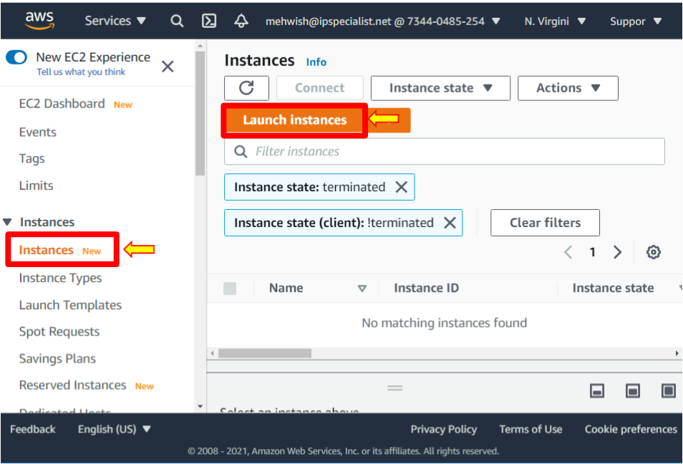

1. In this instance, choose the **Amazon Linux 2 AMI 64-bit**. Click **Select**.

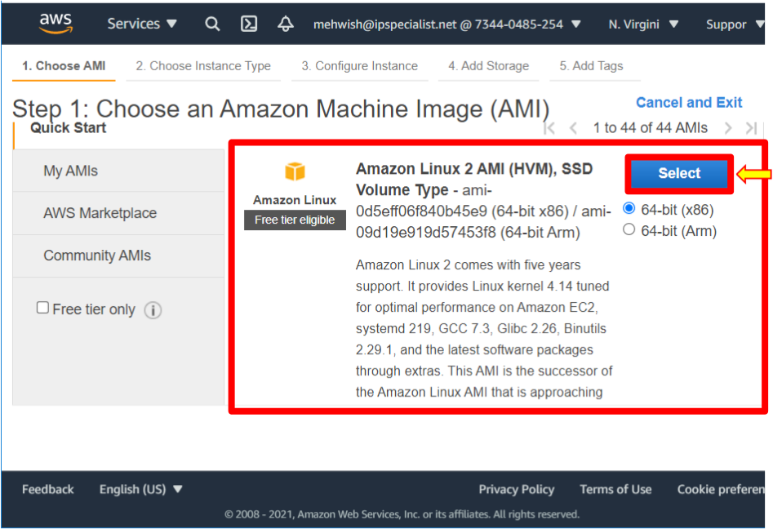

1. In this case, leave the free tier eligible T2 micro selected and click **Next: Configure Instance Details**.

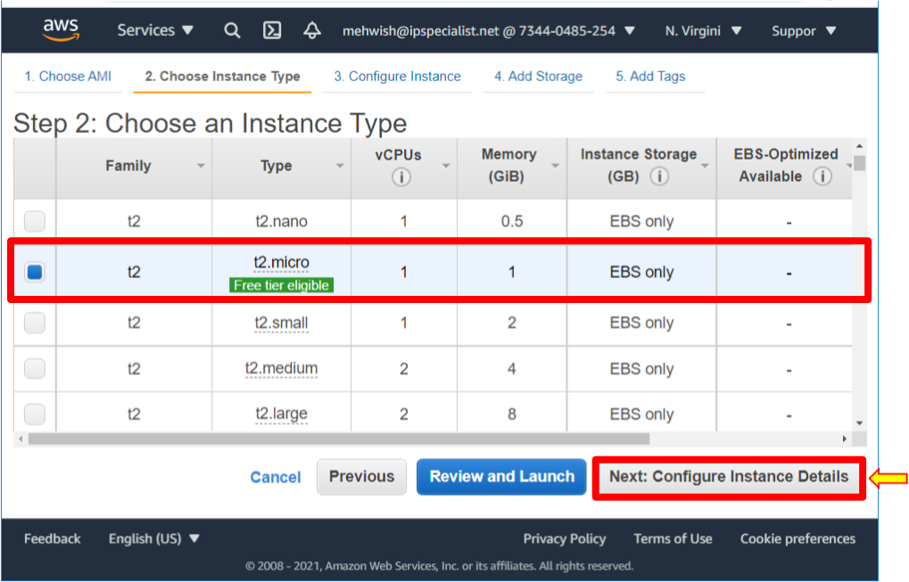

1. Leave all the default number of instances, as we will not request spot instances.
2. For network use, the VPC created **IPS-HoLVPC**.
3. Now, for the subnet, the first step is to create an EC2 launch in the public subnet. Select the drop-down and make sure you have selected **IPS-sn-public-a**.
4. For an auto-assigned public IP, remember to enable it for the subnet. Make sure to use the subnets setting.
5. Scroll down, keep the rest as defaults, and select **Next: Add Storage**.

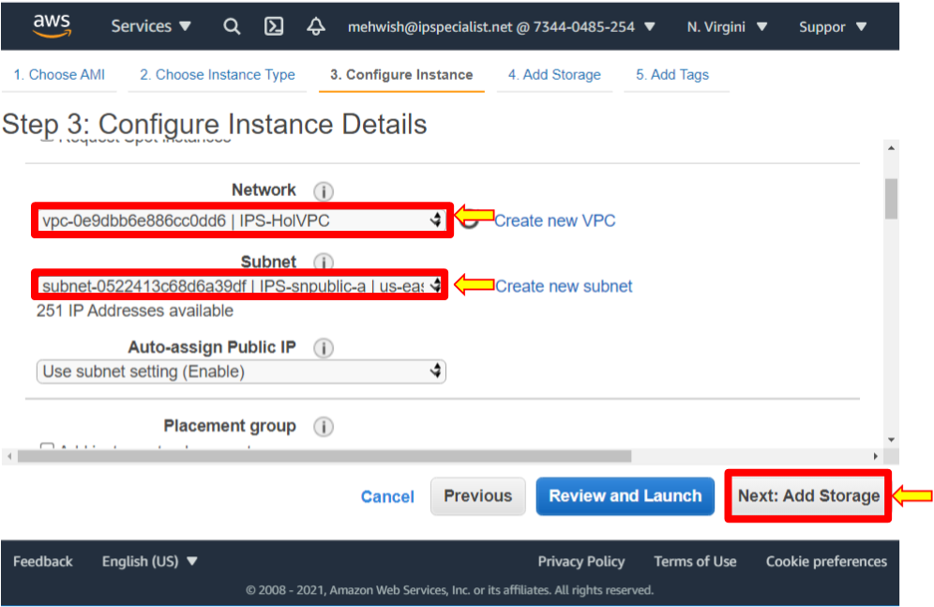

1. It shows the storage that the instance will be launched with.

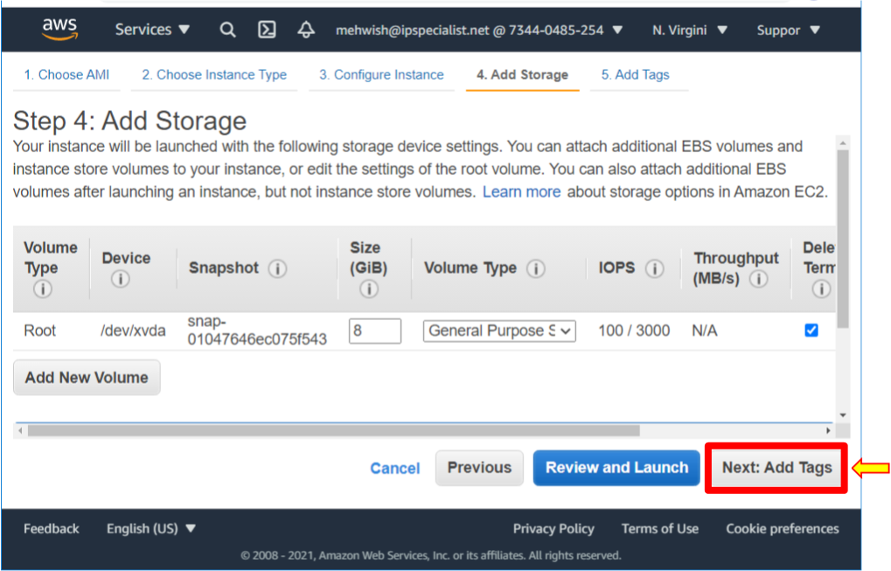

1. Here, you can add a tag like a department name or other useful information that will help you monitor this resource. But for now, we will skip tags.

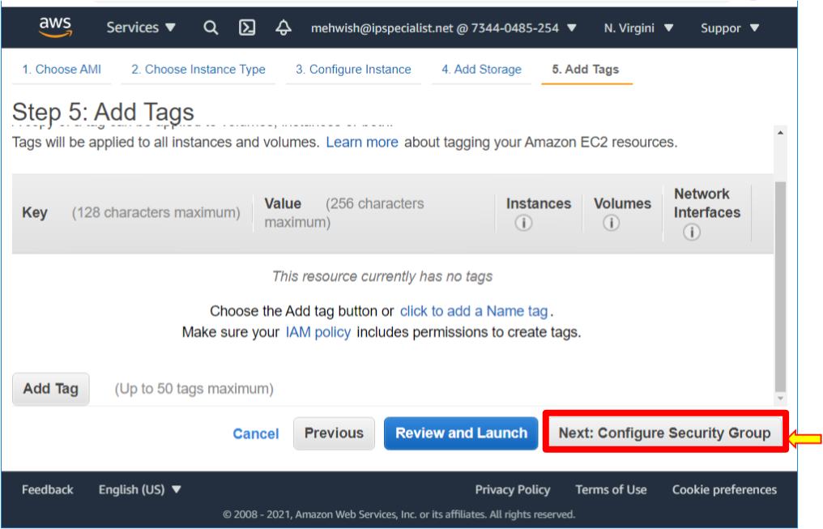

1. Next, configure the **Security Group**. A security group is like a virtual firewall around an EC2 instance. Create a new security group for the selected option, give the security group the name **IPS-holpubSG**, and give the description the same value. It allows SSH, and this is necessary for us to test access. Now notice the source. It essentially allows all IP addresses on the public internet to access your instance. For this lab, this setting is correct because this lab will be shut down. When you launch an EC2 instance, you do not want to leave it open to all IP addresses. It is recommended to set your security group rules to allow access for known IP addresses only. In this case, your IP address or the IP address range for a specific organization. You can add a description if you like, then click **Review and launch**.

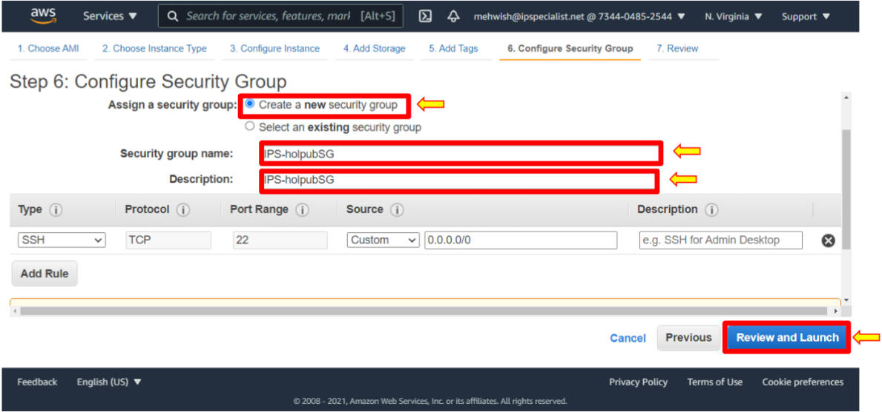

1. Again, this is just a notification that your security group allows anyone on the internet to access your EC2. You can go through the details, storage, and tags. When done, click **Launch**.

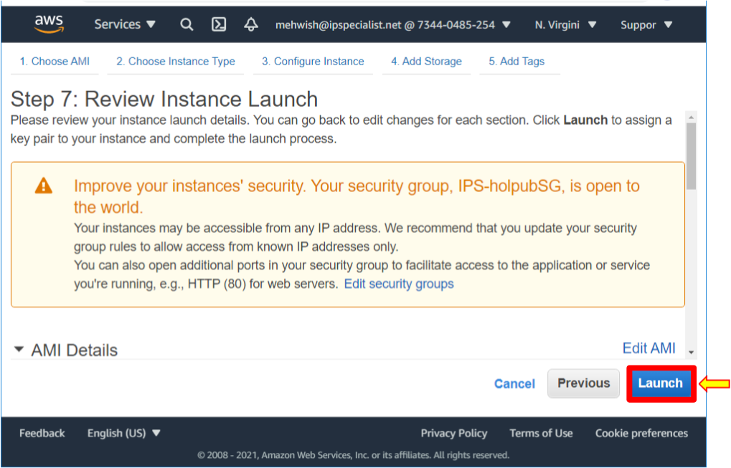

1. Now, this step here is very important. Create a new key pair and download that key pair. Doing this allows us to access our EC2 instance from our local machine. Create a new key pair and name it **IPS-holpubkeypair,** and then click **Download** key pair. It is important to download the key pair because you will not have another opportunity to download it. Notice that it is downloaded into a **.PEM** or PEM file in a secure and accessible location. Click **Launch Instances**.

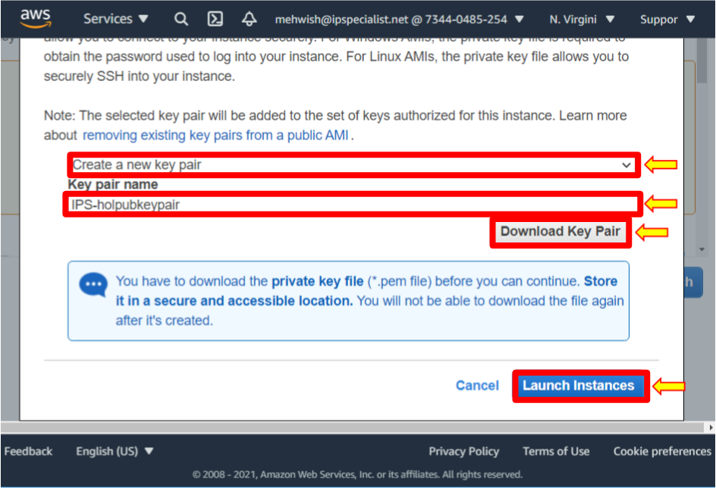

1. Click **View Instances**.

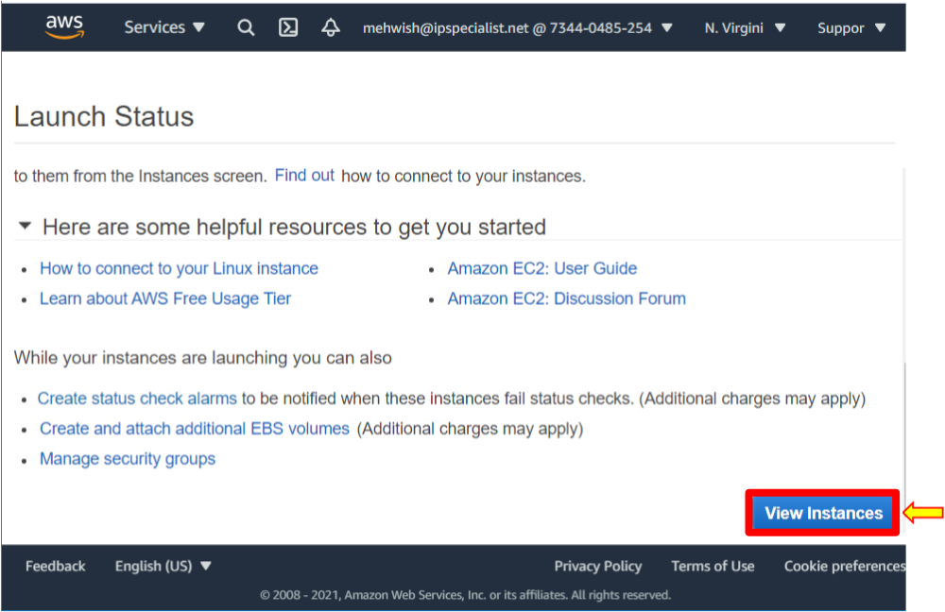

1. Notice here that the instance state is pending.
2. So, while it is launching, go ahead and launch another EC2 instance. But this time, in the private subnet.

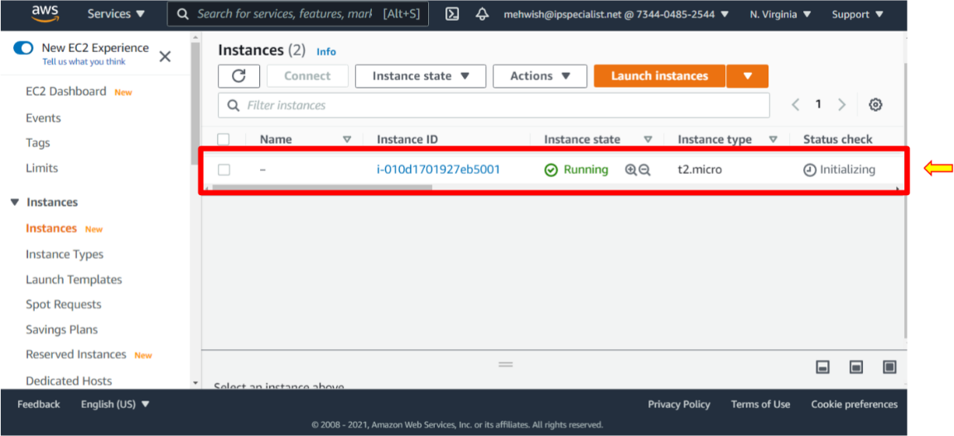

1. Click **Launch Instances** and follow similar steps to what we previously did.
2. Select the **Amazon Linux 2 AMI 64-bit**.
3. Select the **T2 micro** and click **Next: Configure Instance Details**.
4. Select the **IPS-sn-private-b** subnet. For an auto-assigned public IP, use the subnet settings. Notice here that the setting is disabled because this subnet should remain private. As we did before, click **Next: Add Storage**.

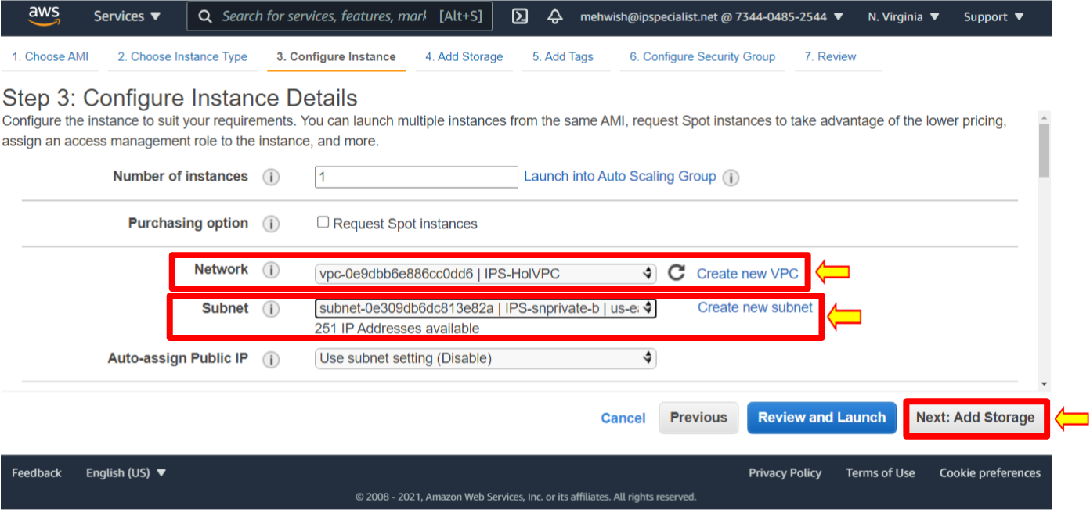

1. Click **Next: Add Tags**.
2. Next, we will configure the security group.
3. For the security group, first, create a new security group name, **IPS-holprivSG,** and add the same name in the **Description** section. Allow SSH to come from this IP address range. Now, notice this is the IP address range **10.0.1.0/24** associated with our public subnet. It means only resources are in the proper subnet IP range. Click **Review and Launch**, review it, and then click **Launch**.

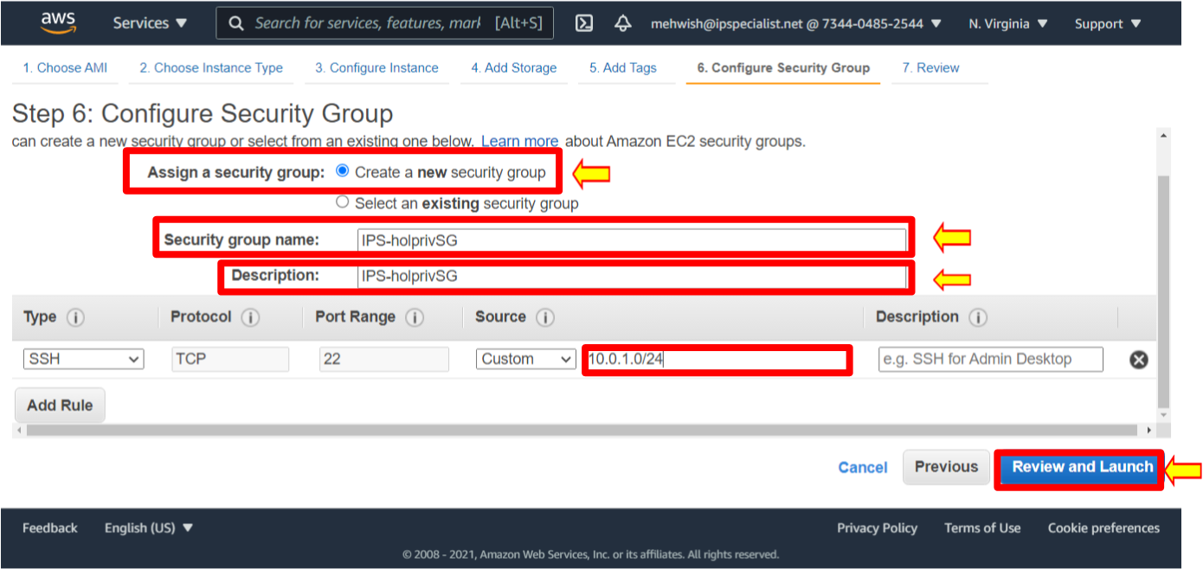

1. Create a new key pair, and instead of naming it the **IPS-holpubleypair**, name it **IPS-holprivkeypair1**. Download this key pair and launch instances.

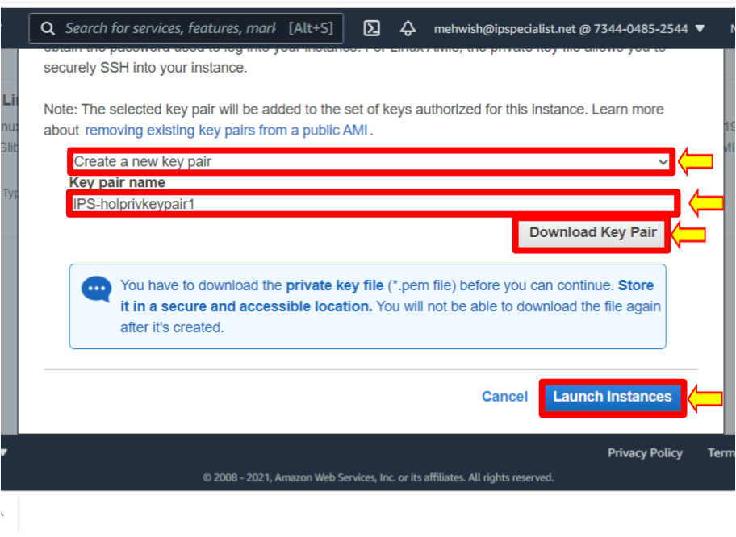

1. Click **View instances**.
2. Once the instance is up and running, copy the public IP address of the public instance to a clipboard. You will need it in the future to log in to the instance.

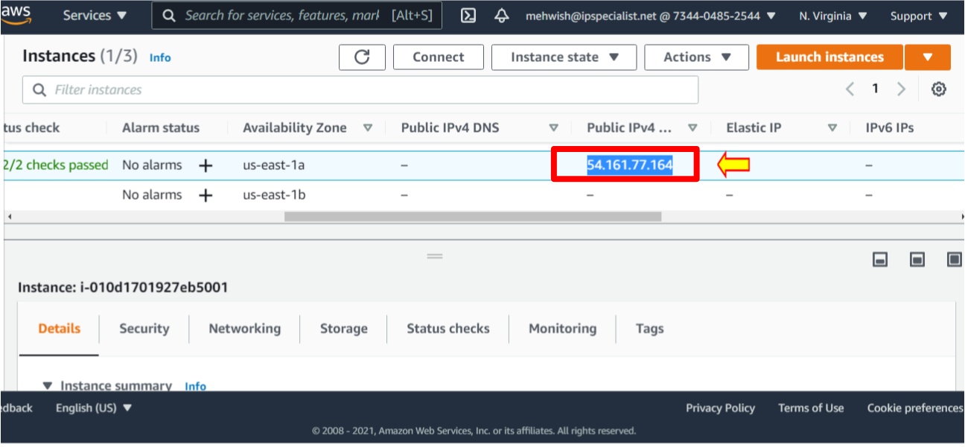

1. Using the key pair that you created, SSH into your EC2 instance. For the Mac platform, follow the instructions on the following link: https://docs.aws.amazon.com/quickstarts/latest/vmlaunch/step-2-connect-to-instance.html.
2. On the Windows platform, open PuTTYgen.
3. Click **Load** to load the existing private key file **IPS-holpubkeypair.pem** you downloaded when creating the EC2 instance. With PuTTYgen, convert **.pem.** file to .**ppk**. file.

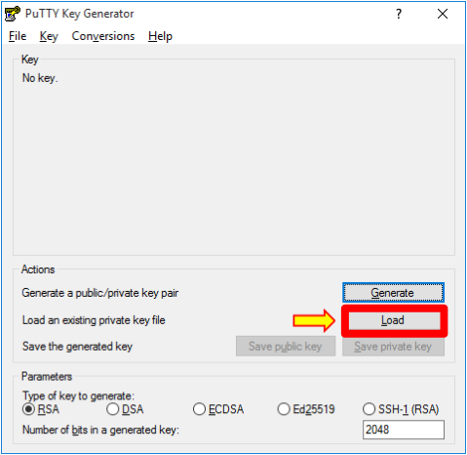

1. Navigate to the folder where your key is, select it, and click **Open**.

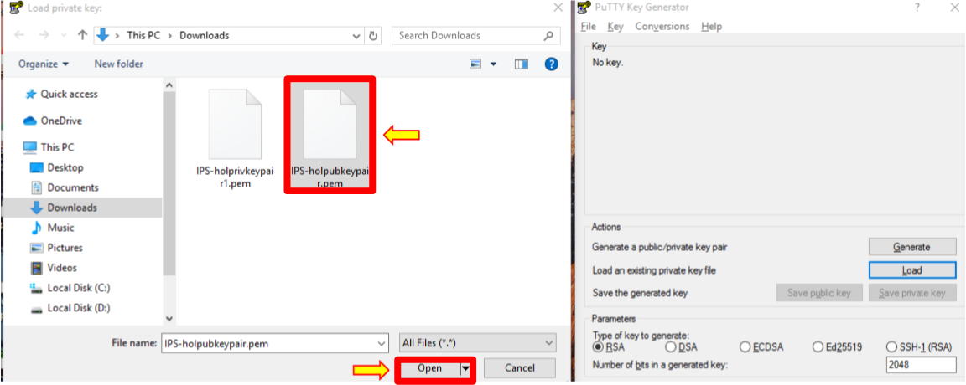



1. A dialogue box will be displayed saying, **Successfully imported foreign key**. Click **OK.**

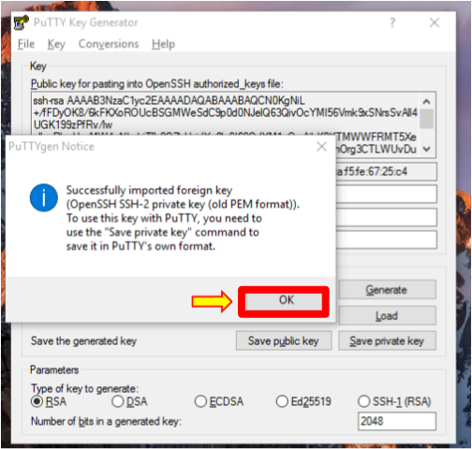

1. Next, you will need to save this private key. Select **Save private key** and click **Yes**.

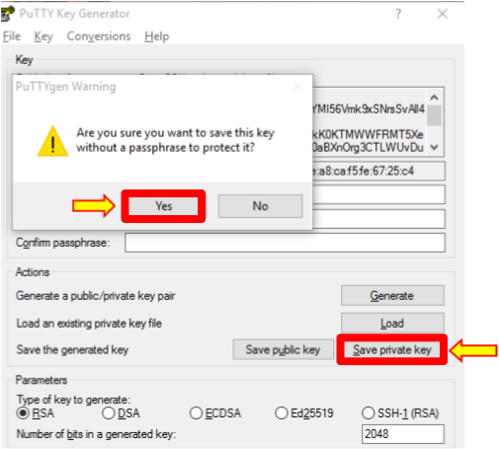

1. Enter the private key name and save it as **IPS-holpubkeypair.ppk** file. Once you are done, close PuTTYgen and open PuTTY.

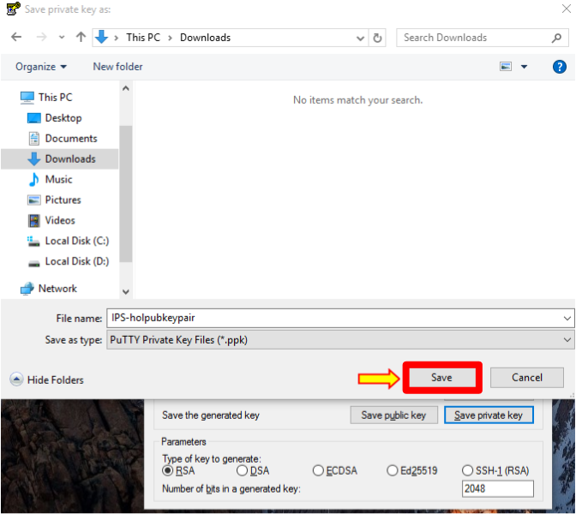

1. Navigate to **SSH** and then **Auth** from the left side of the **Category** pane.

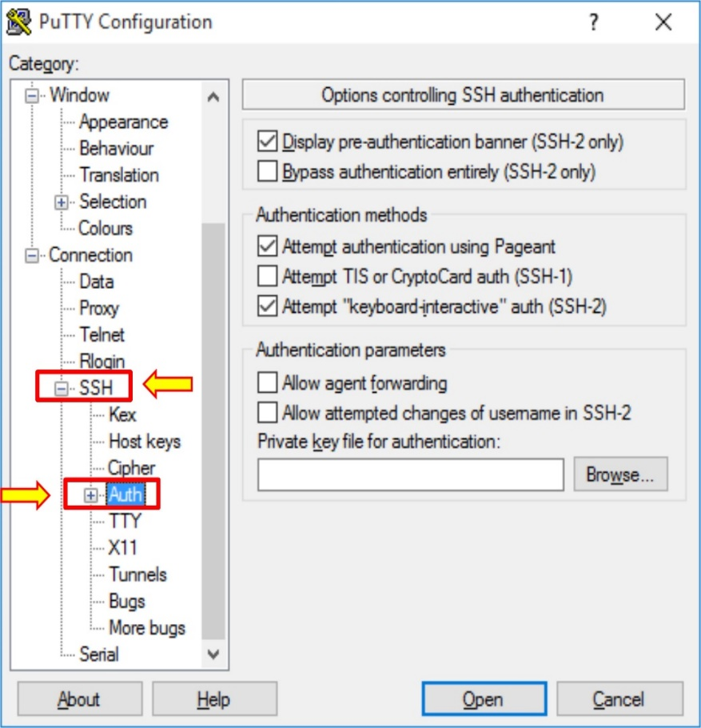

1. Click **Browse** and navigate to the private key file **IPS-holpubleypair.ppk**.
2. Select the key **IPS-holpubkeypair.ppk** and click **Open**. Now, navigate to **Session** from the left side of the category pane.

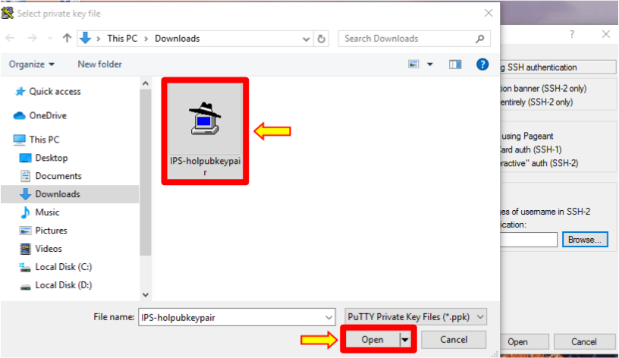

1. Copy the public IP address of the EC2 instance you previously saved in notepad and paste it into the **Host Name (or IP address)** and **Saved Sessions** fields. Click the **Save** button, select the IP address, and click **Open**.

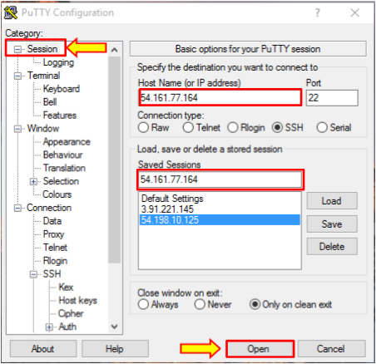

1. The **PuTTy Security Alert** window will open. Click on **Yes** to proceed further.

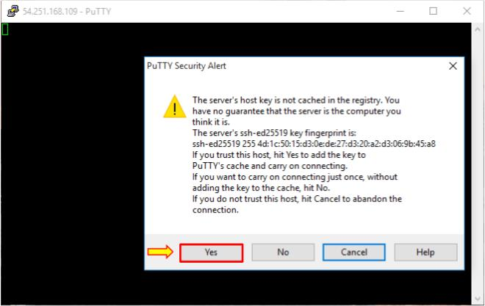

1. It may prompt you for a username, so type in **ec2-user** and hit enter. You will be logged in to your public instance.

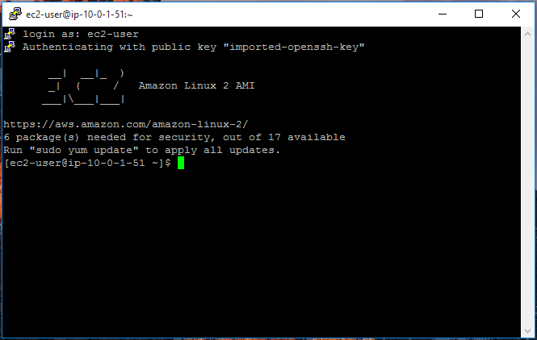

1. Now, let us test the connection to the Private Instance.
2. You should be able to connect to your private instance within the same VPC.
3. Now, this is slightly tricky. Make sure you follow along.
4. Log in to your public instance. To access your private instance, you need a key pair file. Remember to download that key pair file to your local machine.
5. To access your private instance, you must recreate that key pair file on this public EC2 instance.
6. Create a blank key pair file. Use the VI editor to do that and call it the same thing we called previously, **IPS-holprivkeypair1.pem**.

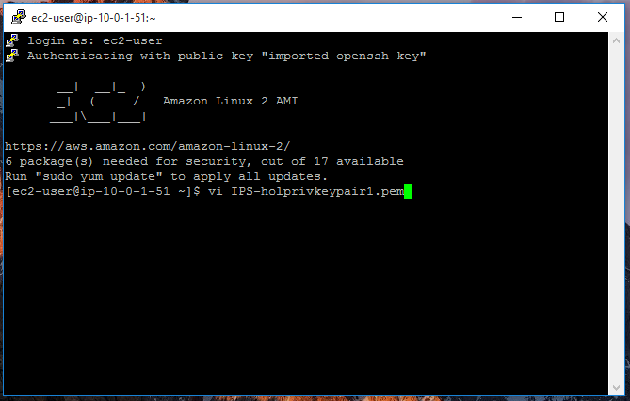

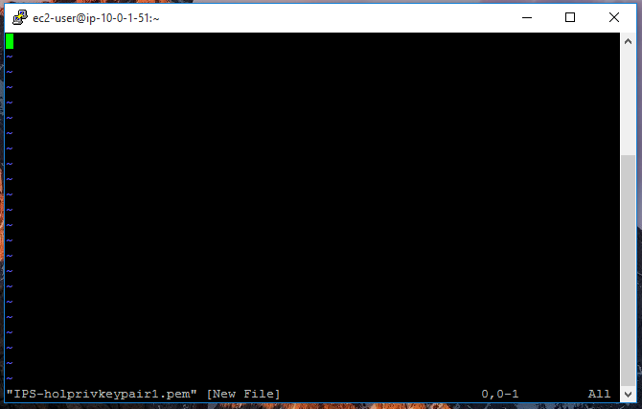

1. This is a blank file. To insert information into this file, press the lowercase **i** on your keyboard. Notice that it is in **insert** mode.

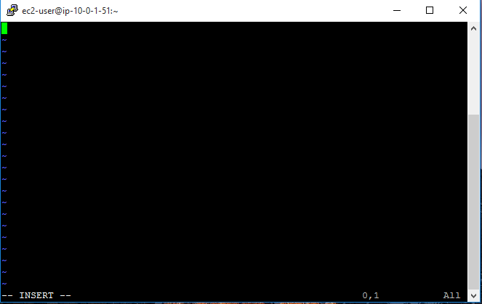

1. Now, go back and open the private key pair file in the text editor. Copy and paste all the content.

This is what the file looks like.

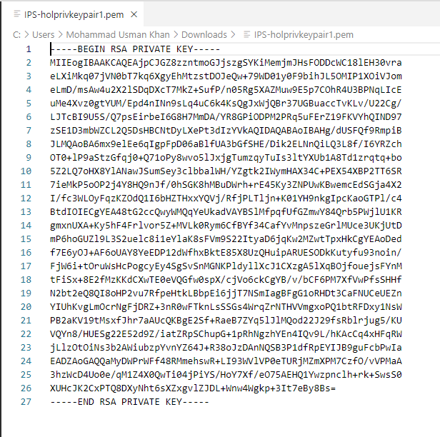

1. Copy everything in this file and paste it here.

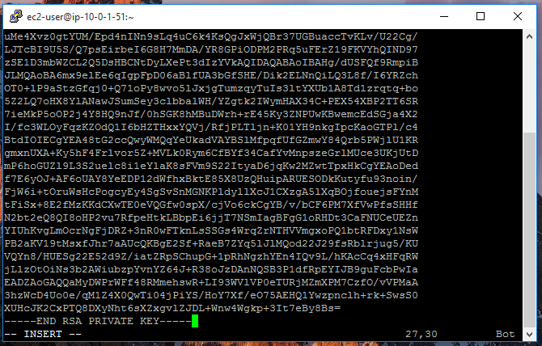

1. To get out of VI insert mode, press the **Esc** key on your keyboard. Then type colon wq (:wq) and press enter.

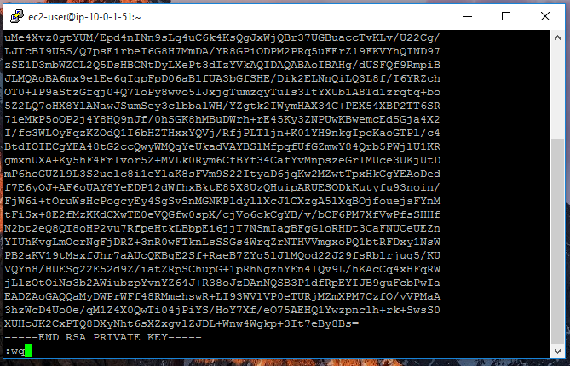

1. The key pair file will be on our public EC2 instance.
2. Before setting the connection string for our private instance, it navigates back to the AWS Management Console.
3. After that, go to the private instance and click connect.

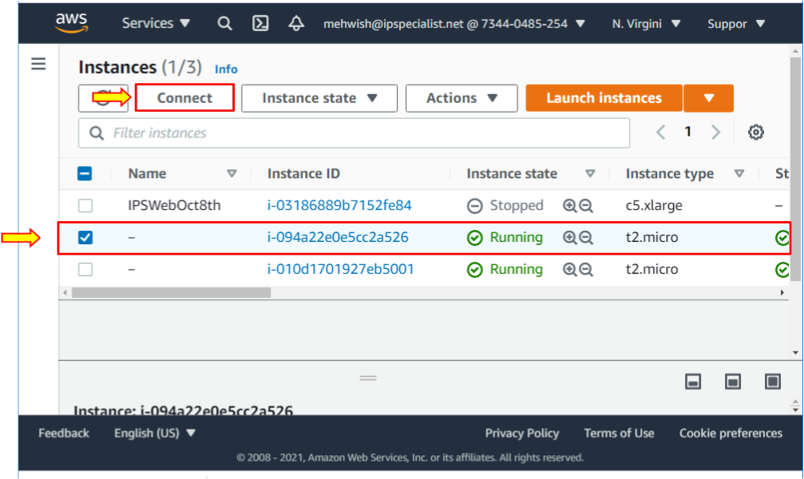

1. Using the SSH client, copy that connection string and then go back to my prompt and paste that connection string. Now, press enter.

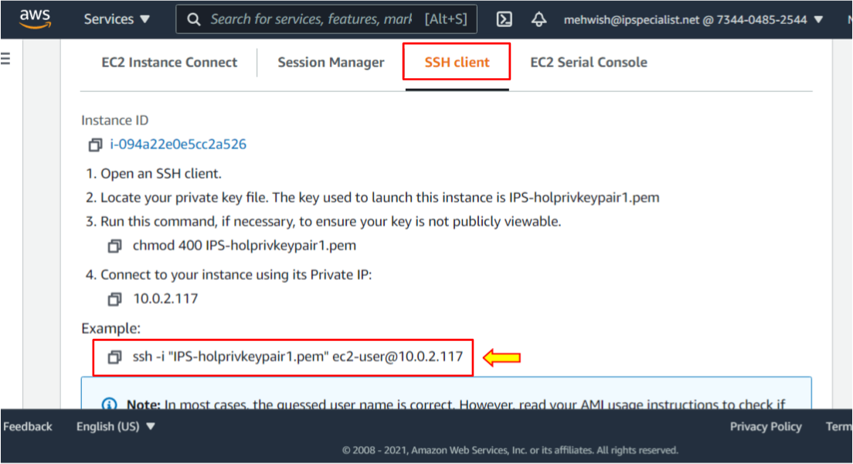

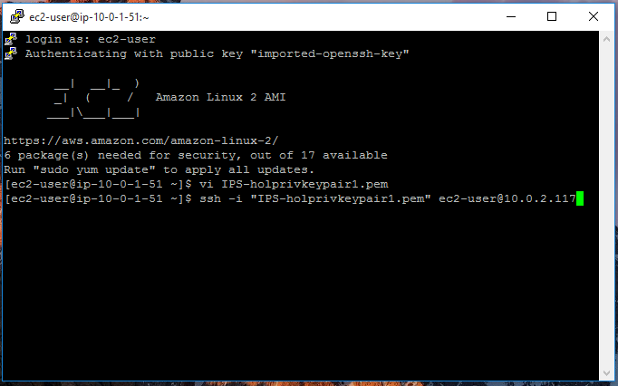

1. Type **Yes**. You will see an error message about an unprotected private key file, and this will happen if you forget to lock down the key pair file.

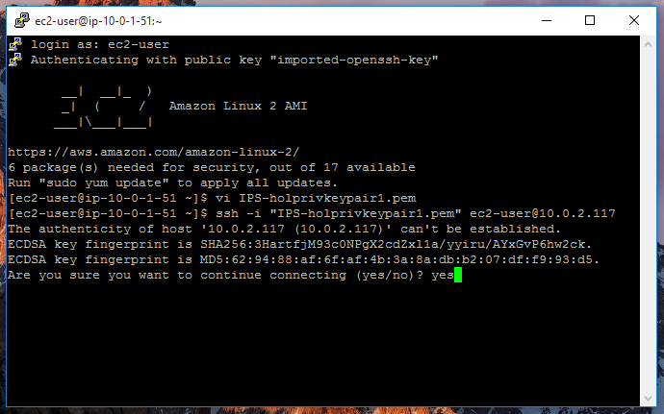

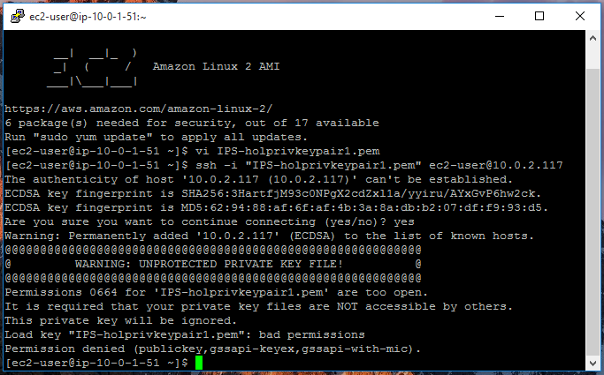

1. To change the permissions on this key pair file, type chmod 400 and the name of the file **IPS-holprivkeypair1.pem**. Press enter.
2. Now, that error should go away.

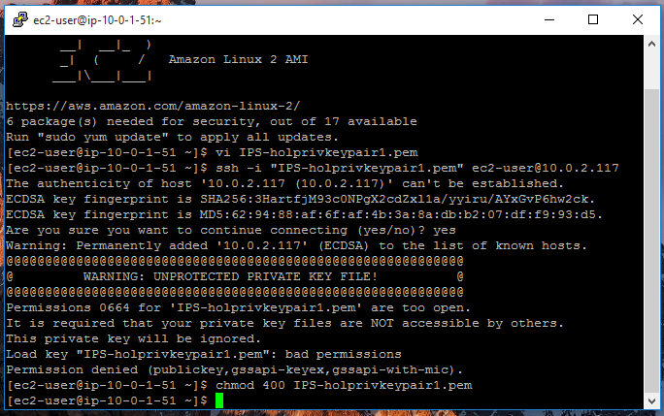

1. Now, pass your connection string and press **Enter**.

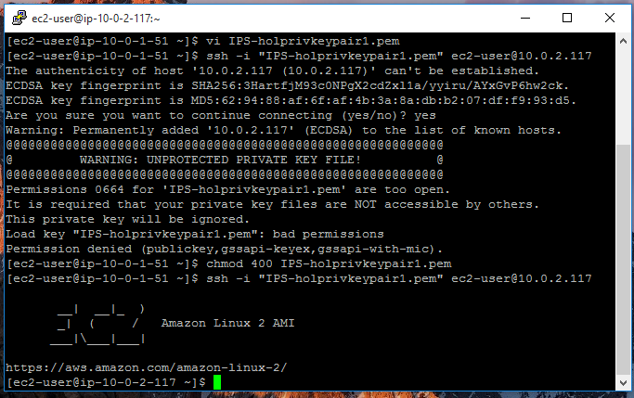

1. You have accessed the private instance from the public instance.

**Lab 02: Create a Site-To-Site VPN Gateway by Using Azure CLI Commands**

**Case Study**

BMW Group is a global automotive manufacturer operating production plants, research centers, and corporate offices worldwide. To support connected vehicle services and modern application development, BMW adopted Microsoft Azure as a core cloud platform. To securely connect its on-premises datacenters with Azure resources, BMW implemented site-to-site VPN connectivity. This solution enabled secure network extension into Azure, ensuring encrypted communication, seamless system integration, and reliable data transfer between hybrid environments. Azure VPN Gateway helped BMW maintain strong security controls while supporting business continuity.

**Business Challenge**

As BMW expanded cloud adoption, it faced difficulties integrating on-premises systems with cloud workloads securely. Data transfers were exposed to security risks, and manual network configurations increased complexity and misconfiguration risks. BMW required a highly secure, automated, and scalable VPN solution that supported command-line deployment. The IT team needed a repeatable approach using Azure CLI to ensure consistent hybrid connectivity across global sites.

**Solution**

In this lab, Azure CLI is used to deploy a site-to-site VPN Gateway. You configure virtual networks, create VPN gateways, define local network gateways, and establish encrypted IPsec tunnels. Using CLI commands, learners automate resource provisioning, update public IP references, configure shared keys, and validate VPN connectivity. Azure VPN Gateway enables BMW to securely extend its on-premises network into Azure, supporting hybrid architectures, disaster recovery, and secure enterprise application access.

Through this lab, learners will practice:

* Creating Azure-side VPN gateways
* Deploying virtual networks and virtual network gateways using Azure CLI
* Configuring local network gateways to represent remote networks
* Updating local network gateway IP references with assigned public IPs
* Establishing secure IPsec VPN connections between Azure and on-premises networks
* Verifying VPN tunnel connectivity

You are now ready to complete your site-to-site VPN gateway by creating the public IP addresses, virtual network gateways, and connections. You initially used placeholders for the public IP addresses in the local network gateways. In this lab, you will update these gateways with the actual public IPs assigned to your virtual network gateways. Ideally, the public IPs and virtual network gateways should be created before the local network gateways. You can also use the same commands to update other configuration elements, such as remote network address spaces.

**Create the Azure-Side VPN Gateway**

First, you will create the VPN gateway for the Azure end of the connection.

|  |
| --- |
| 1. Execute the following command in Cloud Shell to create the **PIP-VNG-Azure-VNet-1** public IP address. |
|  |
| 1. Execute the following command in Cloud Shell to create the **VNG-Azure-VNet-1** virtual network. |
|  |
| 1. Execute the following command in Cloud Shell to create the **VNG-Azure-VNet-1** virtual network gateway. |
|  |

**Create an On-Premises VPN Gateway**

|  |
| --- |
| Next, you will create a VPN gateway to simulate an on-premises VPN device. |
| 1. Execute the following command in Cloud Shell to create the **PIP-VNG-HQ-Network** public IP address. |
|  |
| 1. Run the following command in Cloud Shell to create the **VNG-HQ-Network** virtual network. |
|  |
| 1. Run the following command in Cloud Shell to create **the VNG-HQ-Network** virtual network gateway. |
|  |
| 1. Gateway creation takes approximately 30+ minutes to complete. To monitor the progress of the gateway creation, run the following command. Use the Linux watch command to periodically run the **az network vnet-gateway list** command, enabling you to monitor the progress. |
| You can continue after each VPN gateway shows the Provisioning State of Succeeded. Press **Ctrl+C** to halt the command after the gateway is created. |

**Update the Local Network Gateway IP References**

In this section, you will update the remote gateway IP address references that are defined in the local network gateways. You cannot update the local network gateways until you have created the VPN gateways and an IPv4 address is assigned to and associated with them. Use the following Azure CLI command to check whether both virtual network gateways have been created. The initial state will show Updating. You want to see success on both **VNG-Azure-VNet-1** and **VNG-HQ-Network**.

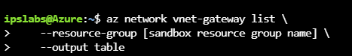

Remember to wait until the lists of gateways are successfully returned. Also, remember that the local network gateway resources define the settings of the remote gateway and network that they are named after. For example, the **LNG-Azure-VNet-1** local network gateway contains information like the IP address and networks for **Azure-VNet-1**.

1. Execute the following command in Cloud Shell to retrieve the IPv4 address assigned to **PIP-VNG-Azure-VNet-1** and store it in a variable.

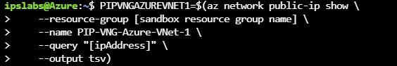

1. Execute the following command in Cloud Shell to update the **LNG-Azure-VNet-1** local network gateway so that it points to the public IP address attached to the **VNG-Azure-VNet-1** virtual network gateway.

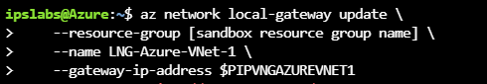

1. Execute the following command in Cloud Shell to retrieve the IPv4 address assigned to **PIP-VNG-HQ-Network** and store it in a variable.

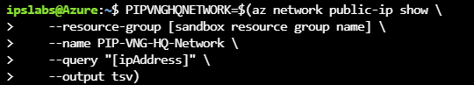

1. Execute the following command in Cloud Shell to update the **LNG-HQ-Network** local network gateway so that it points to the public IP address attached to the **VNG-HQ-Network** virtual network gateway.

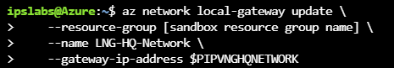

**Create the Connections**

You will now complete the configuration by creating the connections from each VPN gateway to the local network gateway that contains the public IP address references for that gateway's remote network.

|  |
| --- |
| 1. Create the shared key to use for the connections. In the following command, replace **<shared key>** with a text string to use for the IPsec pre-shared key. A string of printable ASCII characters with a length of no more than 128 characters is used as the pre-shared key. This pre-shared key must be used on both connections. |
|  |
| 1. Remember that **LNG-HQ-Network** contains a reference to the IP address of your simulated on-premises VPN device. Execute the following command in Cloud Shell to create a connection from **VNG-Azure-VNet-1** to **LNG-HQ-Network**. |
|  |
| 1. Remember that **LNG-Azure-VNet-1** contains a reference to the public IP address associated with the **VNG-Azure-VNet-1** VPN gateway. This connection would normally be created from your on-premises device. Execute the following command in Cloud Shell to create a connection from **VNG-HQ-Network** to **LNG-Azure-VNet-1**. |
|  |
| The configuration of the site-to-site link is now complete. The tunnels should automatically link and become active after a few minutes. |

**Verification Steps**

Let us confirm that the VPN tunnels are connected.

|  |
| --- |
| 1. Run the following command to confirm that Azure-VNet-1-To-HQ-Network is connected. |
|  |
| The site-to-site configuration is now complete. |

**Lab 03: Set Up Disaster Recovery with Azure Site Recovery**

**Case Study**

Grupo Universal, a major insurance and financial services provider in the Dominican Republic, recognized the importance of maintaining continuous operations in the face of IT failures and outages. To support business continuity and comply with its risk management policy, the company adopted a disaster recovery strategy leveraging Microsoft Azure Site Recovery (ASR). With Azure Site Recovery, Grupo Universal was able to protect its critical workloads by replicating virtual machines and data to the cloud, ensuring rapid failover and continued application availability during both planned and unplanned disruptions. The implementation of ASR allowed the company to manage replication across virtual machines from different systems and virtualization platforms without maintaining costly secondary infrastructure.

**Business Challenge**

Grupo Universal faced challenges common to enterprises with mission-critical applications: ensuring system availability during outages, minimizing downtime, and protecting data integrity without the expense and complexity of maintaining a fully redundant secondary datacenter. The IT team needed a solution that could replicate production workloads to a secure, cloud-based environment, enable controlled failover and failback, and support diverse virtualized systems. Additionally, the solution had to support compliance requirements while offering a manageable and automated disaster recovery process.

**Solution**

In this lab, Azure Site Recovery is used to demonstrate how a company like Grupo Universal can implement a disaster recovery strategy that meets enterprise continuity requirements. Site Recovery allows replication of virtual machines to a secondary Azure region or environment, enabling failover when the primary system becomes unavailable. The process includes creating a Recovery Services vault, configuring replication settings, enabling VM replication, and testing failover. Azure Site Recovery supports continuous data replication, automated failover/failback, and monitoring of replication health. By using ASR, enterprises can reduce the operational cost of traditional disaster recovery infrastructure, improve RTO and RPO objectives, and ensure business continuity in the face of IT disruptions. The official Azure Site Recovery documentation provides detailed guidance on planning, enabling replication, and managing recovery workflows.

Through this lab, learners will gain practical experience to:

* Create and configure a Recovery Services Vault
* Enable replication for Azure virtual machines
* Customize the target region and cache storage
* Monitor replication jobs and health status

**Create a Recovery Services Vault**

1. Sign in to the Azure portal.
2. On the Azure Portal’s homepage, under Azure services, select **Create** **a resource**.

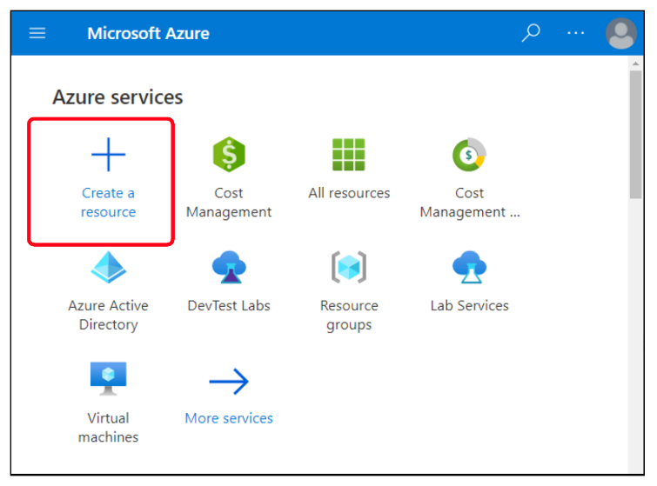

1. The **Create a resource** pane will appear.
2. In the left menu pane, select **IT & Management Tools** and click **Backup and Site Recovery** under Popular services.

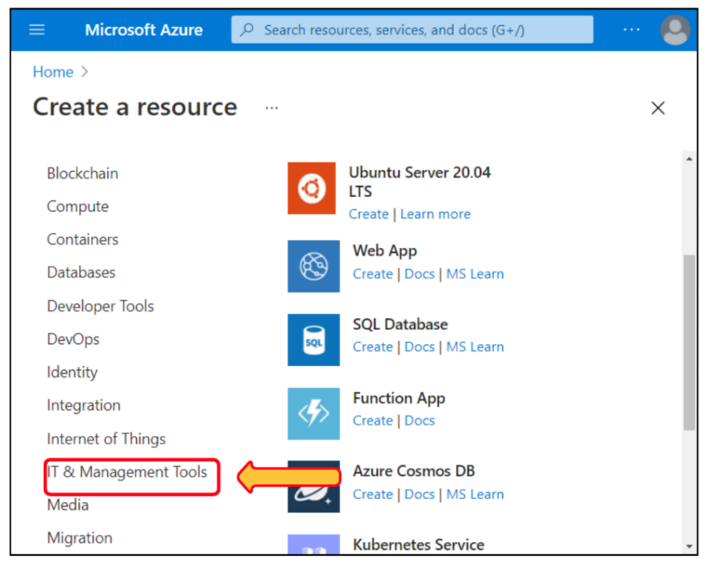

1. The **Create Recovery Services** vault pane will appear.

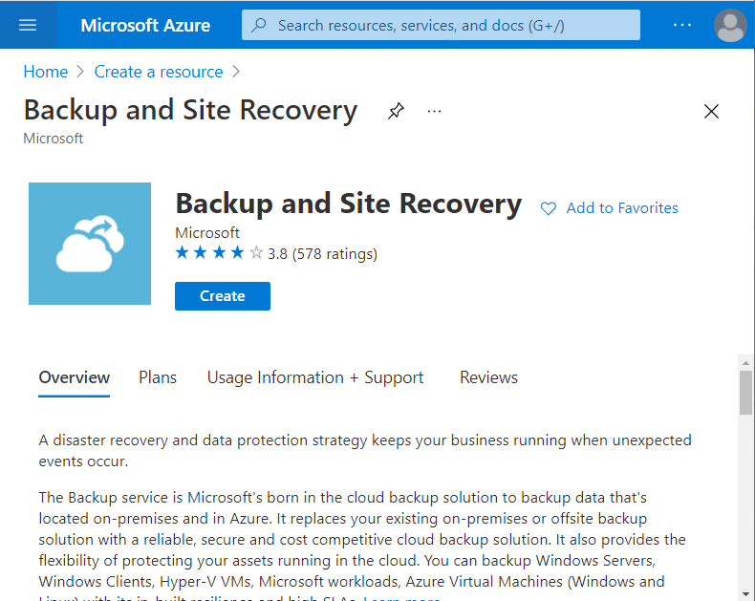

1. Click on **Create**.

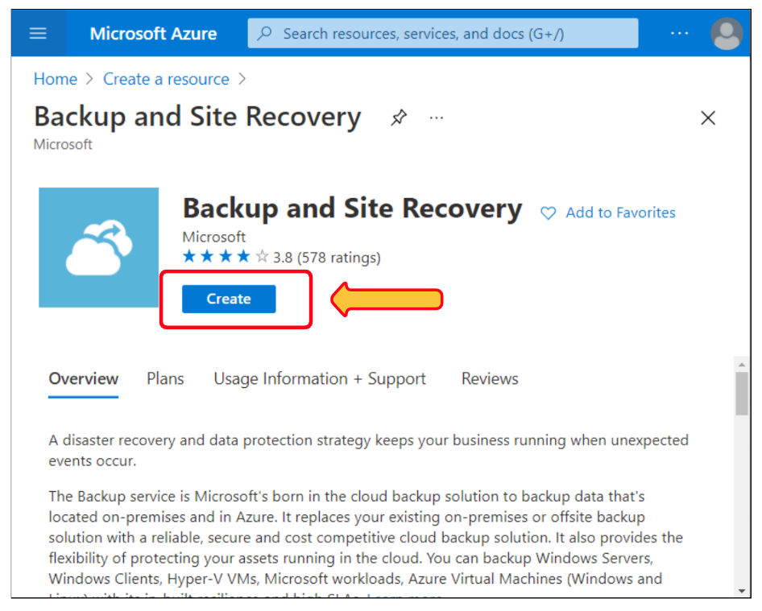

1. On the Basics tab, enter the following values for each setting.

**Setting Value**

**Project Details**

Subscription your subscription

Resource group Select east-coast-rg, and then select OK.

**Instance Details**

Vault name asr-vault

Region East US 2

1. Select **Review + create**.

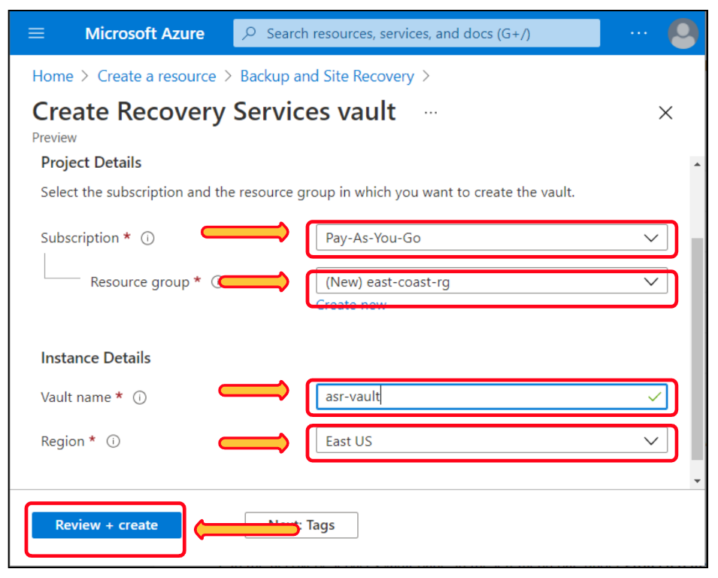

1. Select **Create**.

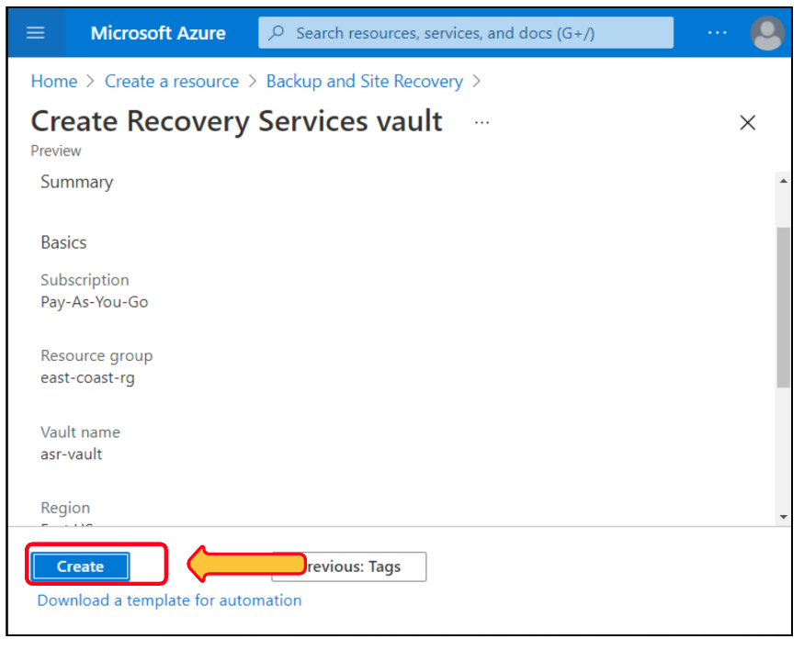

1. After completing the deployment, select **Go to resource** to view the recovery services vault.

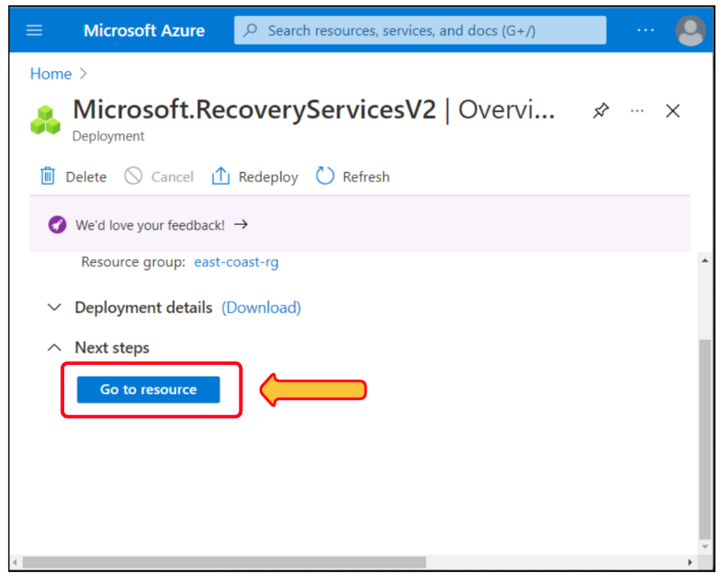

**Enable Replication**

1. In the Recovery Services vault pane, in the left menu bar, under Protected items, select **Replicated items**.

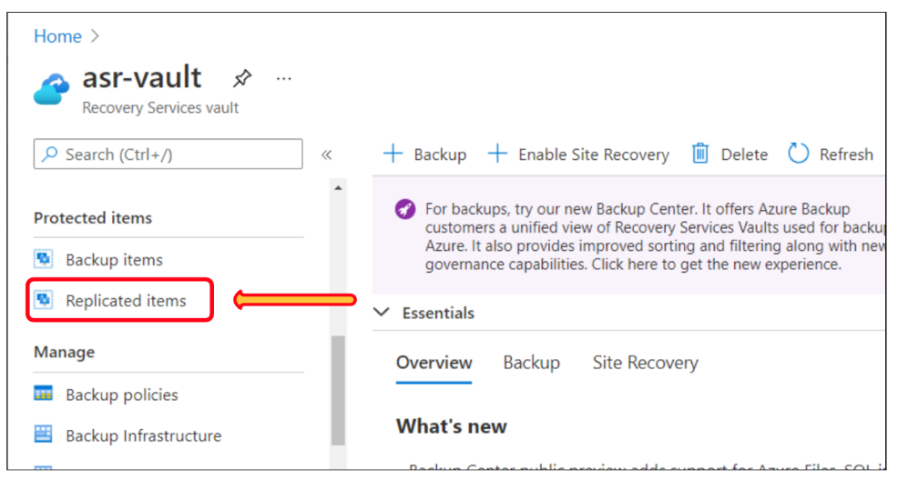

1. The **Replicated items** pane will appear.

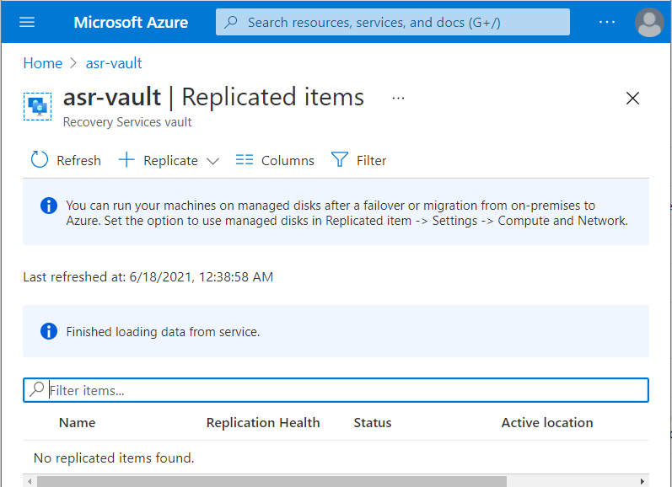

1. In the top menu bar, select **Replicate**.
2. From the dropdown list, select **Azure virtual machines**.

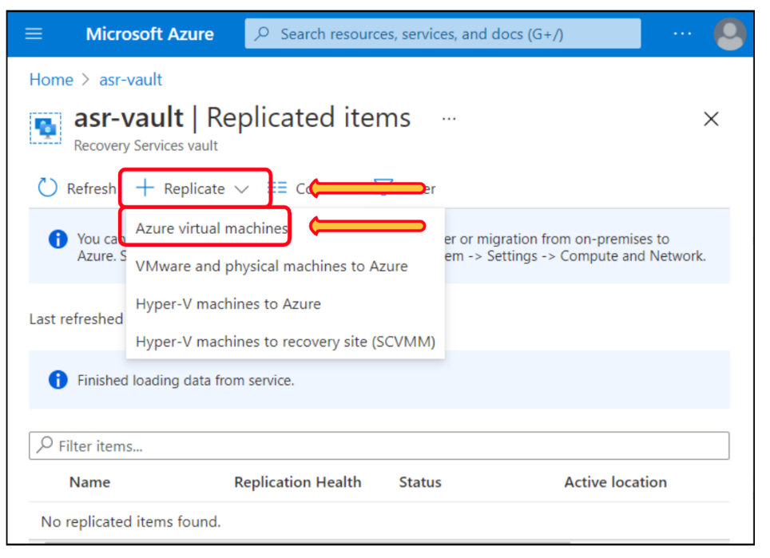

1. Enter the following values for each setting.

**Setting Value**

**Source tab**

Source location🡪 West US 2

Source resource group-🡪 west-coast-rg.

Select **Next**.

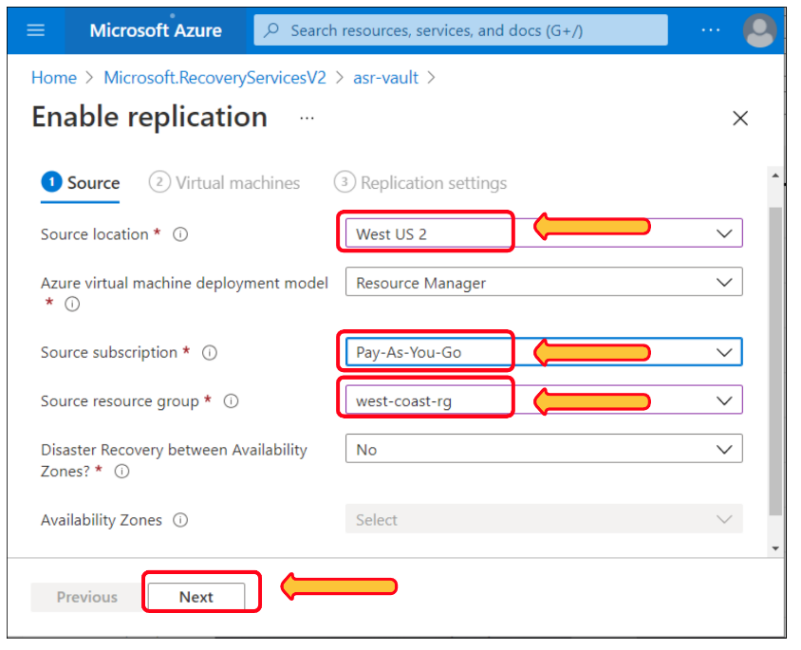

**Virtual machines tab**

Select both VMs 🡪 hr-records and patient-records.

Select **Next**.

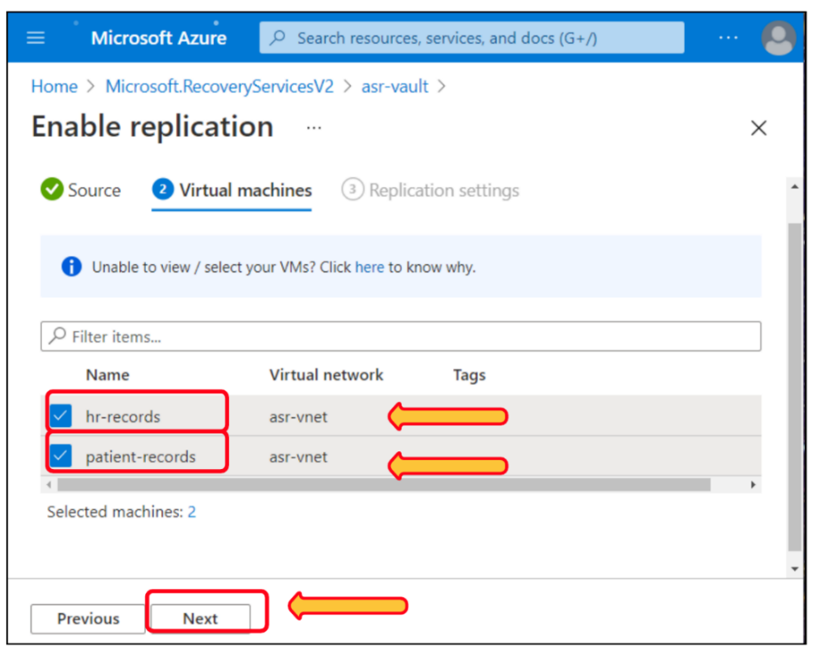

**Replication settings tab**

Target location 🡪 **East US 2**.

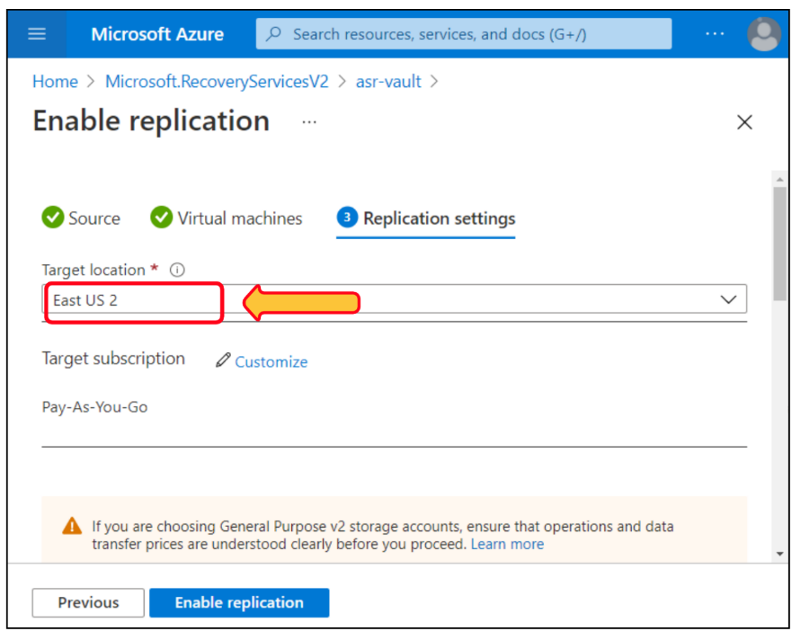

Customize 🡪 Select it. The Customize target settings pane appears.

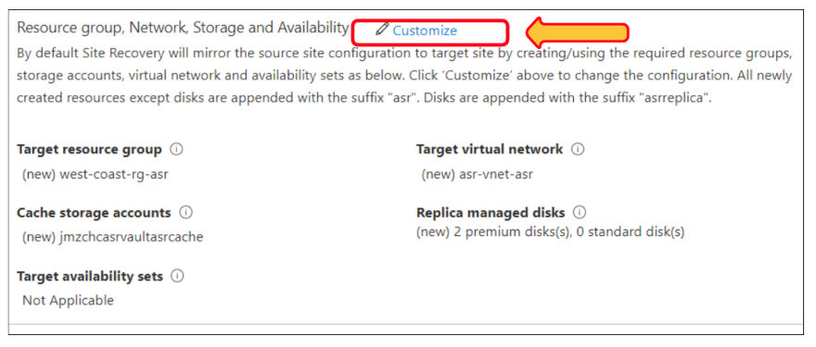

Target resource group 🡪 **east-coast-rg**

For each VM 🡪 From the dropdown list, change the Cache storage to **asrcacheXXXX**, where **XXXX** is a random number. Select **OK**.

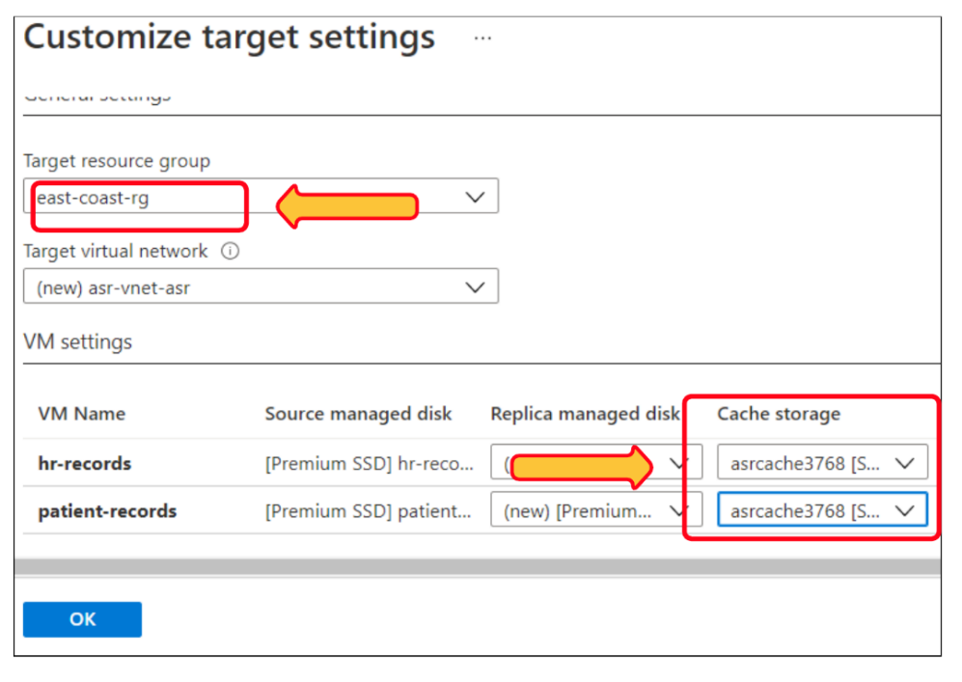

1. Select **Enable replication**.

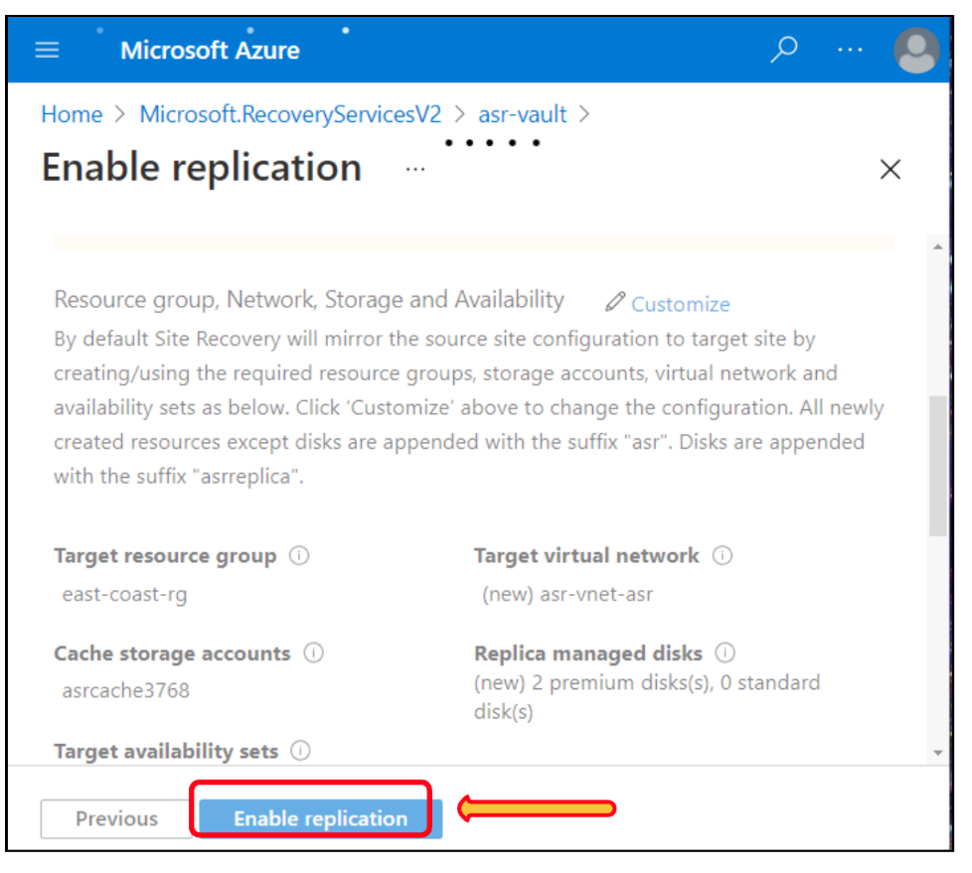

**Monitor replication progress**

1. Select **Home** on the top menu to return to the portal's home page.

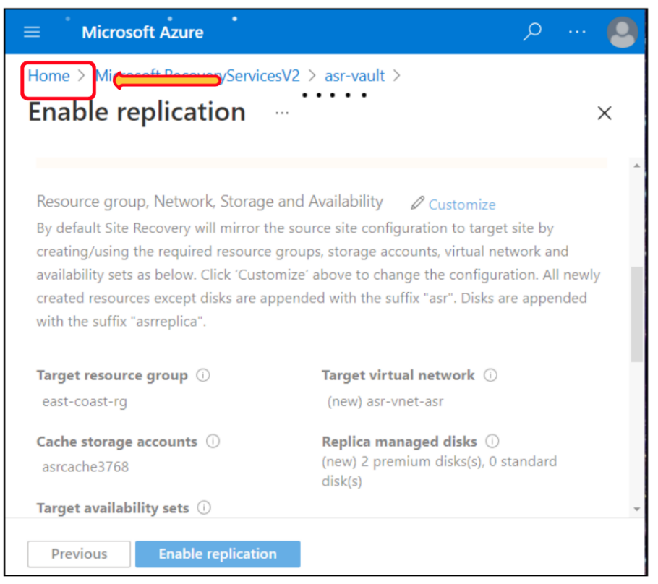

1. Select **All resources**.

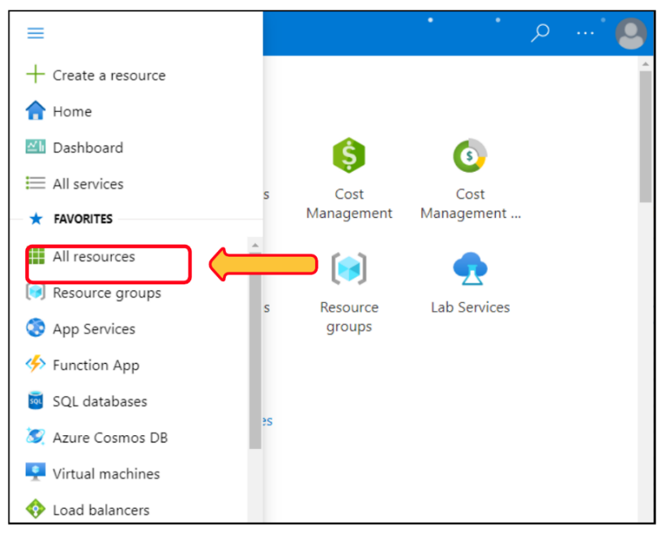

1. In the list of resources, select the **Recovery Services** vault named **asr-vault**.

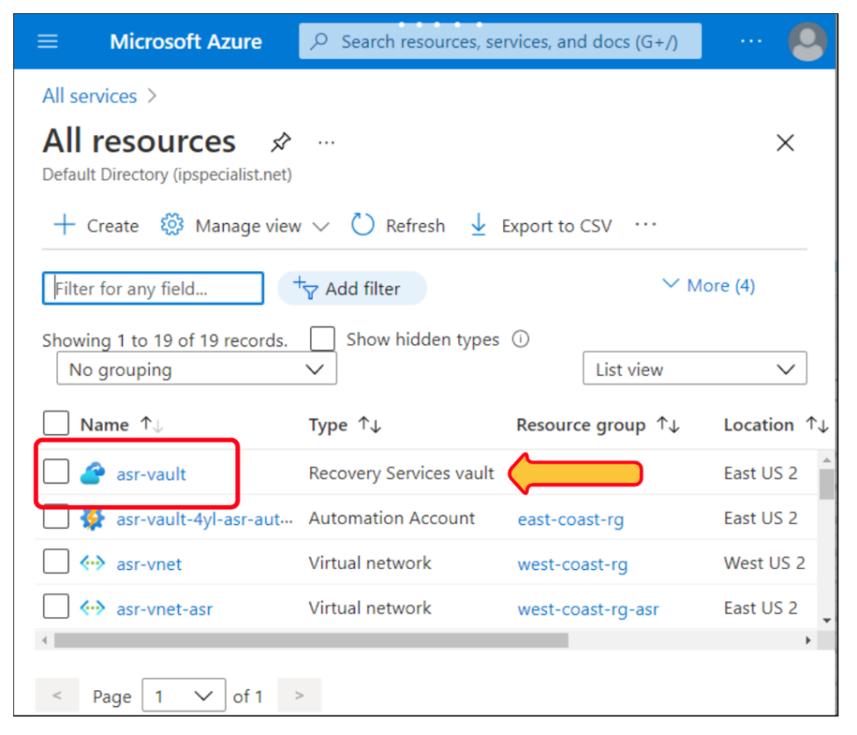

1. In the left menu pane, under Monitoring, select **Site Recovery jobs**.

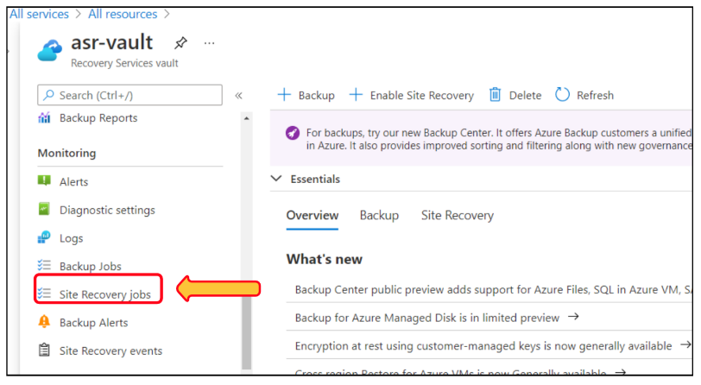

1. In the jobs list, select the **In progress** link to view how the replication setup is progressing.

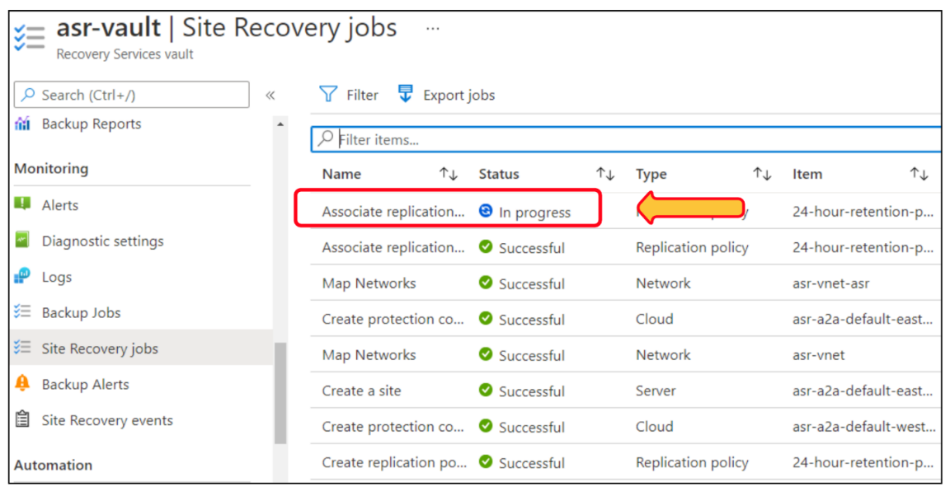

1. You can select any of the listed jobs to view more details.

